Statistical Aide Memoire
(for those not deliberately ill informed)



Do not believe politicians or bureaucrats, look at the facts, here are some on the great topics of the day.
Introduction

After many years of speaking at schools and universities one of the things that strikes me most is the difficulty of pupils, undergraduates and faculty alike having access to accurate, up to date and impartial information. People are turning away from the historical sources of information. BBC National TV has such a marked political bias from the environment to the economy it is barely worth watching unless you want re-runs of Dad’s Army.
The popular press of course continue as undisguised advocates of one mainstream Westminster political party or the other. Local radio, TV and press struggle nobly with information based non partisan work but into the headwind of disinformation from the establishment.
The statistics in this aide memoire are all in the public domain somewhere. I am very fortunate to have professionally minded friends whose jobs depend on their advice being impartial and accurate.
The current financial crisis could not have transpired if main stream journalism had not betrayed their clientele. Most of what has happened in the last few years was predicted by a small number of pundits without access to high profile media. I am such a one.
In years to come the great climate change debate (scam?) will be reflected on in much the same way as the fiscal crisis is today. We will all be searching for the advocates in vain as we are now for the perpetrators of the monstrous political post war assault on the thrifty, old, bewildered middle England electorate of today.
A big thank you to those who brought these stats to my attention, and indeed continue to update me.

What does one TRILLION dollars look like?

All this talk about "stimulus packages" and "bailouts"...
A billion dollars...
A hundred billion dollars...
Eight hundred billion dollars...
One TRILLION dollars...
What does that look like? I mean, these various numbers are tossed around like so many doggie treats, so I thought I'd take Google Sketchup out for a test drive and try to get a sense of what exactly a trillion dollars looks like.
We'll start with a $100 dollar bill. Currently the largest U.S. denomination in general circulation. Most everyone has seen them, slighty fewer have owned them. Guaranteed to make friends wherever they go.
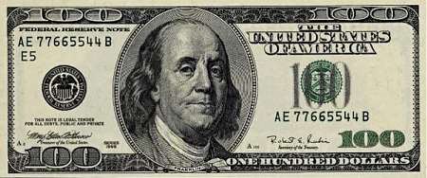

A packet of one hundred $100 bills is less than 1/2" thick and contains $10,000. Fits in your pocket easily and is more than enough for week or two of shamefully decadent fun.
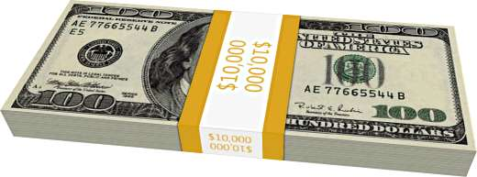
Believe it or not, this next little pile is $1 million dollars (100 packets of $10,000). You could stuff that into a grocery bag and walk around with it.
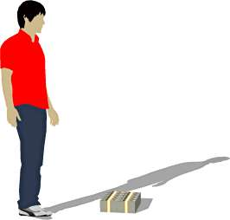
While a measly $1 million looked a little unimpressive, $100 million is a little more respectable. It fits neatly on a standard pallet...
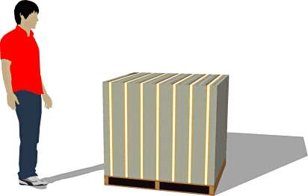

And $1 BILLION dollars... now we're really getting somewhere...
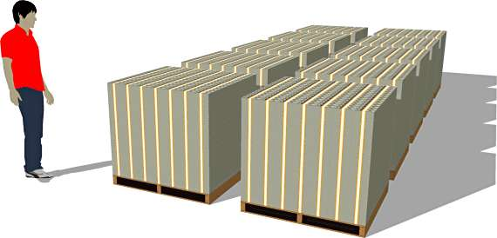

Next we'll look at ONE TRILLION dollars. This is that number we've been hearing so much about. What is a trillion dollars? Well, it's a million million. It's a thousand billion. It's a one followed by 12 zeros.
You ready for this?
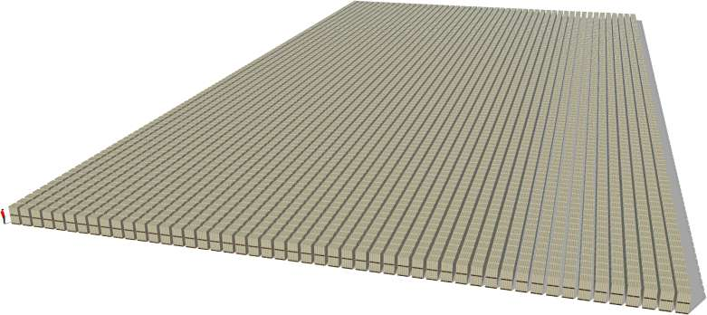
It's pretty surprising.
Go ahead...
Ladies and gentlemen... I give you $1 trillion dollars...

Notice those pallets are double stacked.
...and remember those are $100 bills.
So the next time you hear someone toss around the phrase "trillion dollars"... that's what they're talking about.

In order of % of GDP the Eurostat stuff reads:

Greece: €329bn debt, which accounts for 145 per cent of GDP. Unemployment stands at 17 per cent and youth unemployment is 43 per cent.
Italy: €1,843bn debt, which accounts for 118 per cent of GDP. Unemployment stands at 8 per cent and youth unemployment is 28 per cent.
Ireland: €148bn debt, which accounts for 95 per cent of GDP. Unemployment stands at 15 per cent and youth unemployment is 32 per cent.
Portgual: €161bn debt, which accounts for 93 per cent of GDP. Unemployment stands at 12 per cent and youth unemployment is 27 per cent.
Germany: €2,062bn debt, which accounts for 83 per cent of GDP. Unemployment stands at 6 per cent and youth unemployment is 8.9 per cent.
France: €1,591bn debt, which accounts for 82 per cent of GDP. Unemployment stands at 10 per cent and youth unemployment is 24 per cent
United Kingdom: €1,337bn debt, which accounts for 81 per cent of GDP. Unemployment stands at 8 per cent and youth unemployment is 21 per cent. N.B.
Spain: €642bn debt, which accounts for 61 per cent of GDP. Unemployment stands at 21 per cent and youth unemployment is 46 per cent.

N.B. UK debt is significantly more than this but ‘private funding initiatives’ are off balance sheet.

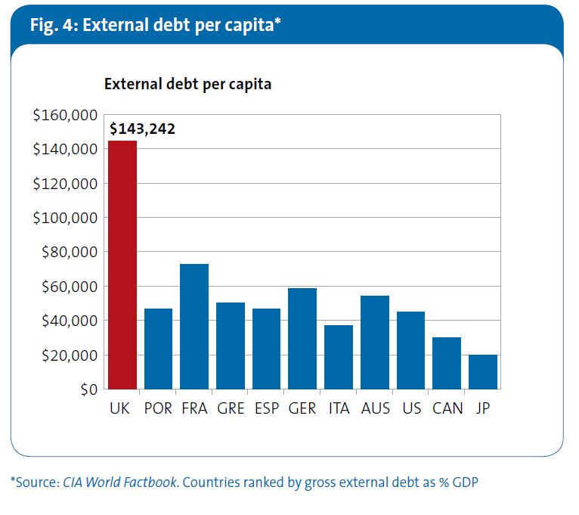

External debt is a more immediate danger for an economy as the debt and therefore currency is subject to international confidence which can literally crumble in 24 hours. This is a truly terrifying figure.

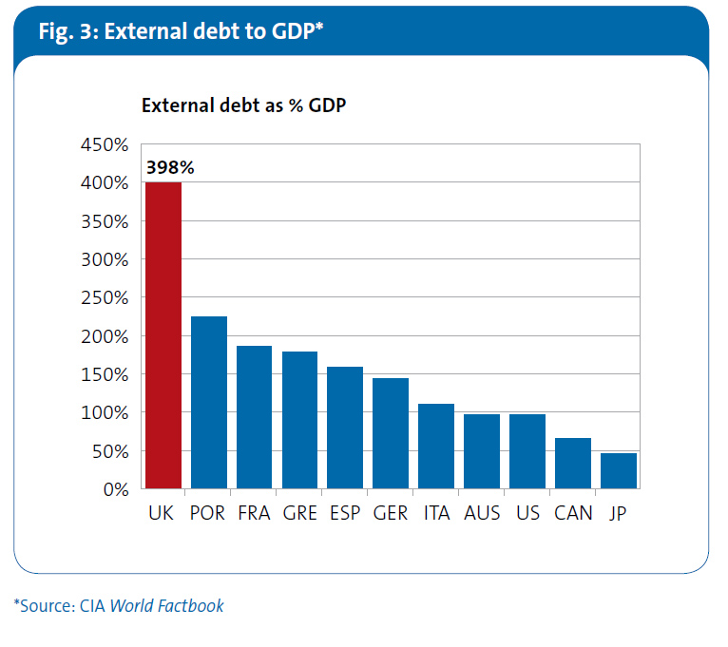

Whilst markets fixate on Ireland, Portugal, Greece, Italy and Spain the UK position is equally appalling if not more so. International markets have not yet focussed on this but they will and soon.

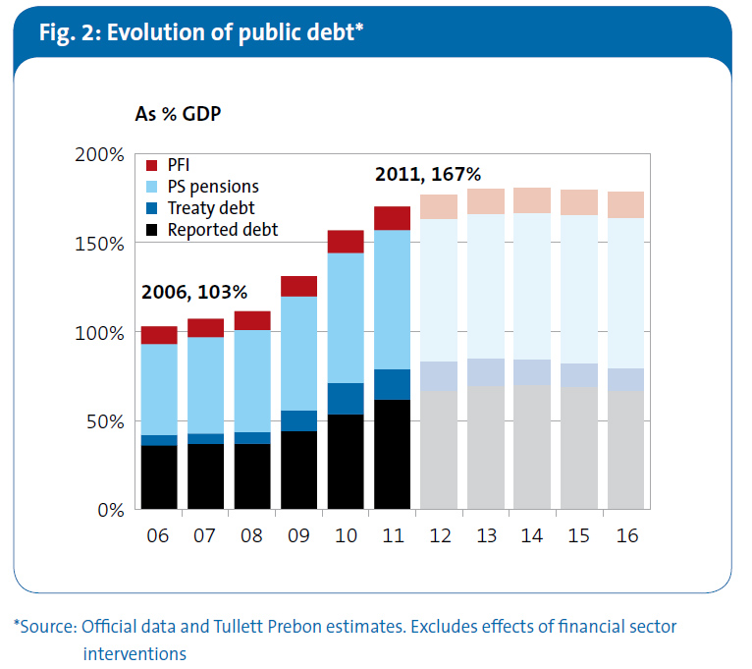

Public debt is growing. The public perception encouraged by public sector broadcasting gives the electorate the impression that it is diminishing. Quite wrong. These figures exclude the banking crash which politicians blame for the crisis, albeit banking regulators and the central bank were and are appointed by politicians.

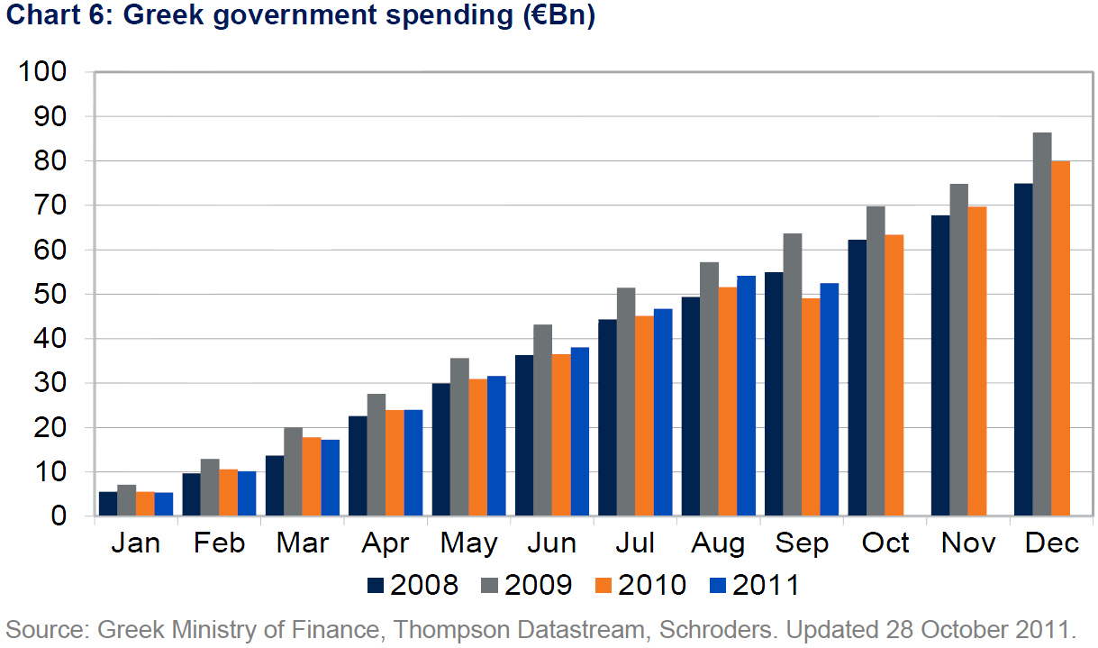

This hologram shows Greek government spending is marginally increasing month by month, again against public perception.

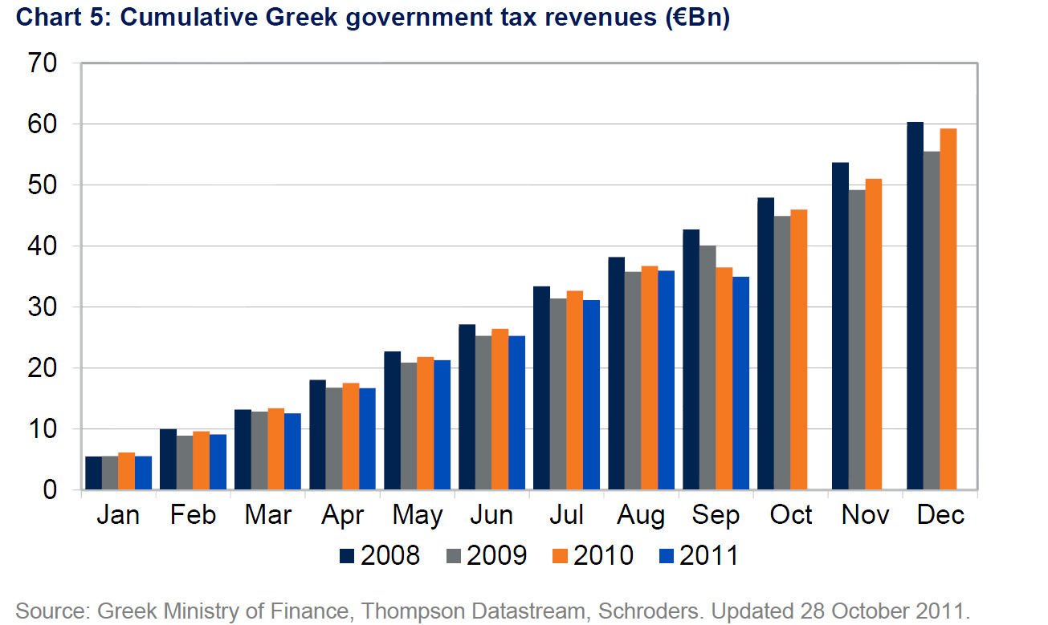

Tax revenue is decreasing.

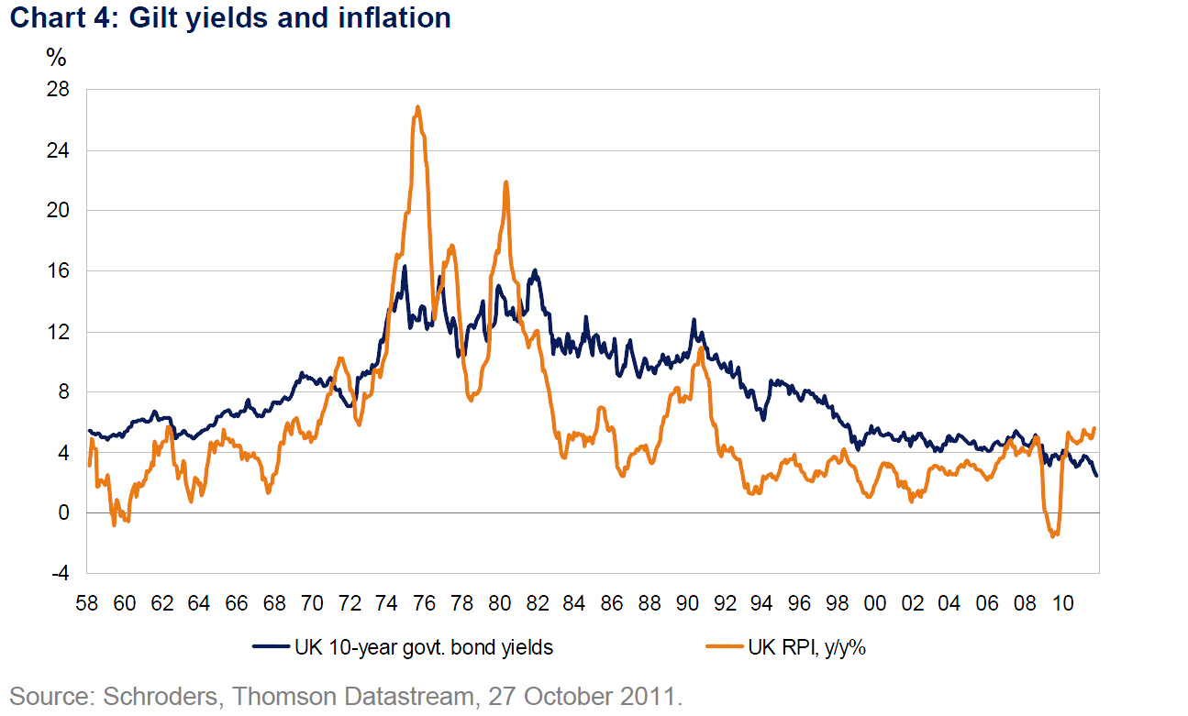

This chart is the worrying trend of high inflation and low gilt yields. Reminiscent of the dreadful 1970s. This punishes those on fixed incomes, pensioners and savers in particular.

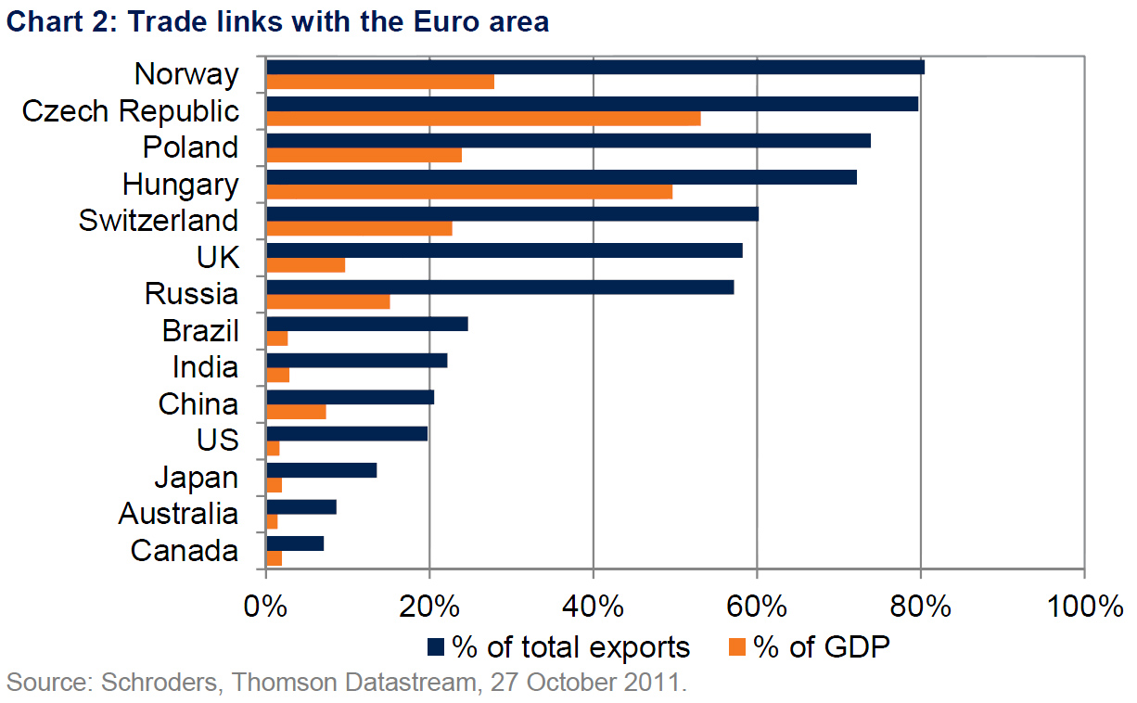

This hologram completely kills the myth that the UK is somehow dependant on EU export jobs. We are actually below 2 non members Switzerland and Norway!
As a % of GDP less even than Russia.

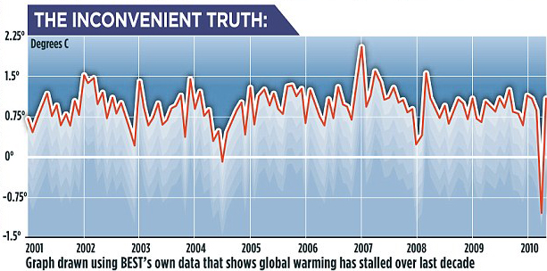

The United Kingdom pursues a suicidal energy policy. Billions in ‘green tax’ ludicrous spend on wind turbines and solar, yet where is the man made global warming? This is an excellent training graph for those who like to fake statistics for the lazy or unwary.
This graph you will never see on the BBC.

“If it’s a Yes, we will say ‘on we go’, and if it’s a No we will say ‘we continue’”
– JEAN-CLAUDE JUNCKER
“Dealing with a banking crisis was difficult enough, but at least there were public-sector balance sheets on to which the problems could be moved. Once you move into sovereign debt, there is no answer; there’s no backstop”
– Mervyn King
“The euro is a very solid currency which has kept its value remarkably over time, its domestic value and its international value, and nobody, it seems to me, is challenging the euro as a currency”
– Jean-Claude Trichet
“We all know what to do, we just don’t know how to get re-elected after we’ve done it”
– JEAN-CLAUDE JUNCKER
“Monetary policy is a serious issue. We should discuss this in secret, in the Eurogroup [...] I’m ready to be insulted as being insufficiently democratic, but I want to be serious [...] I am for secret, dark debates”
– Jean-Claude Juncker

“In questions of power, let no more be heard of confidence in man, but bind him down from mischief by the chains of the Constitution.”
– Thomas Jefferson
“I cannot undertake to lay my finger on that article of the Constitution which granted a right to Congress of expending, on objects of benevolence, the money of their constituents”
- James Madison

"Politics is the art of looking for trouble, finding it everywhere, diagnosing it incorrectly, and applying the wrong remedies. “ -Groucho Marx

Again, quotes you will never hear on Auntie BEEB (the Brussels Broadcasting Corporation)
Ask any school pupil or British undergraduate about Magna Carta, the Bill of Rights or the Act of Settlement and they will simply stare vacantly at you, as will their teachers. A classic example of the state inspired box ticking approach to ‘education’.
All you Need to Know about Government Bureaucracy:--
* * Pythagorean theorem: ...............................24 words.
* * Lord's Prayer:.........................................................66 words.
* * Archimedes' Principle: ............................67 words.
* * 10 Commandments: ............................179 words.
* * Gettysburg address: ...........................286 words.
* * US Declaration of Independence : ......1,300 words.
* * US Constitution with all 27 Amendments: ...7,818 words.
* * EU regulations on the sale of cabbage:................. 26,911 words.
SORT OF PUTS THINGS INTO PROPER PERSPECTIVE, DOESN'T IT?

There are even now school teachers and easily impressed pupils who think ‘The European Union is broadly a force for good’. No doubt the power of millions of Euros put into school propaganda.

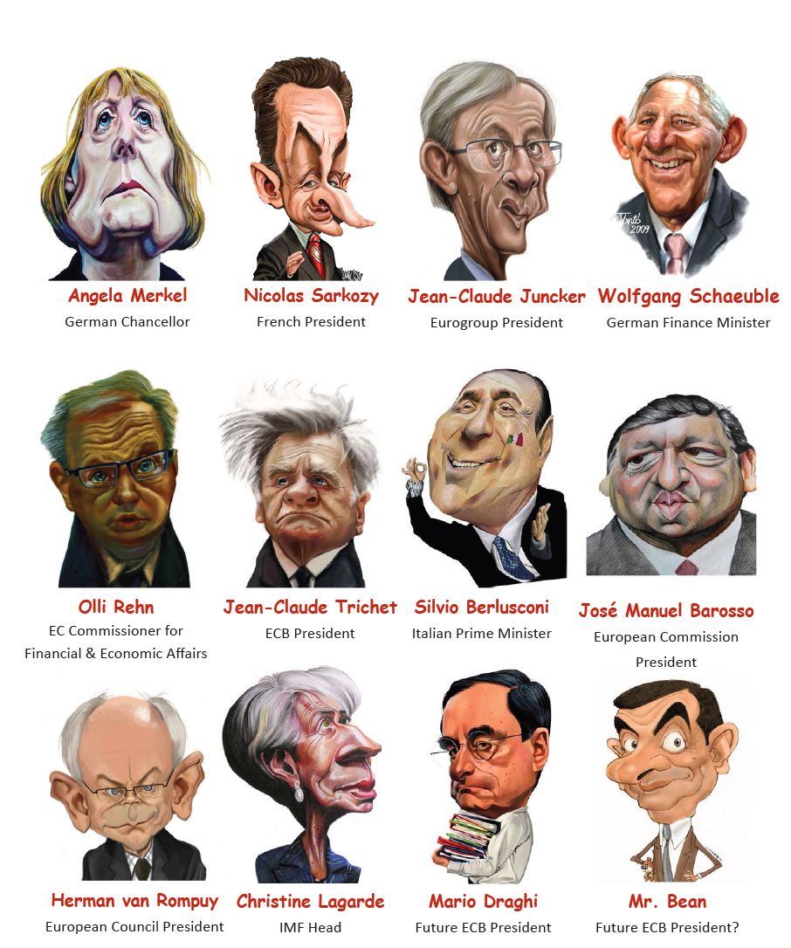

When the whole thing breaks up, as it is now doing, these are the people who should go on trial.

The Hague Court, actually no, a tribunal for economic crimes. Nuremburg would suggest itself as an apposite venue.

Gordon Brown’s sale at under $300.
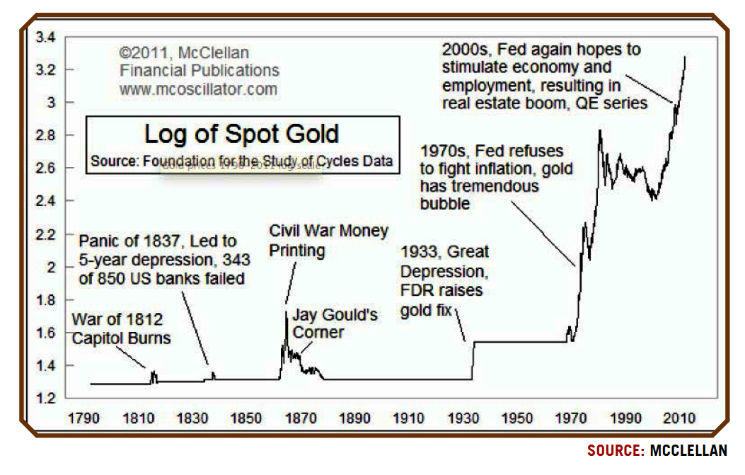

When paper money collapse gold is the only call. Gordon Brown’s great sale of your gold.

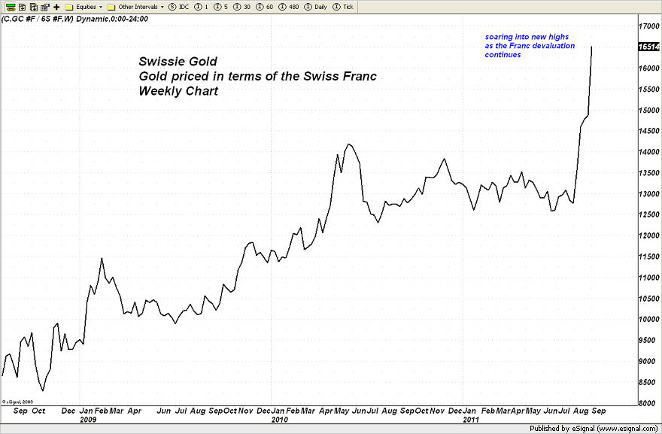

This meteoric rise in gold against the Swiss Franc coincides with crooked Swiss Politicians linking the Franc to the Euro.

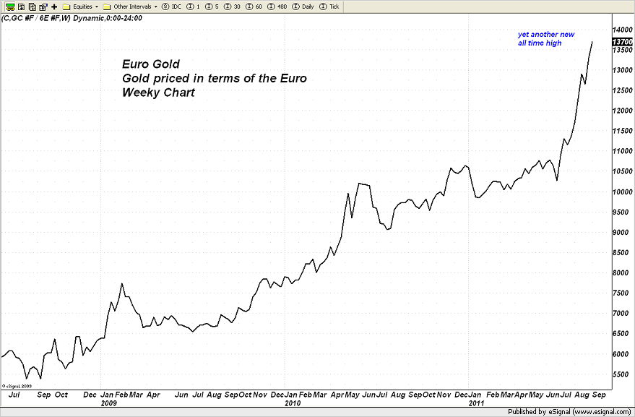
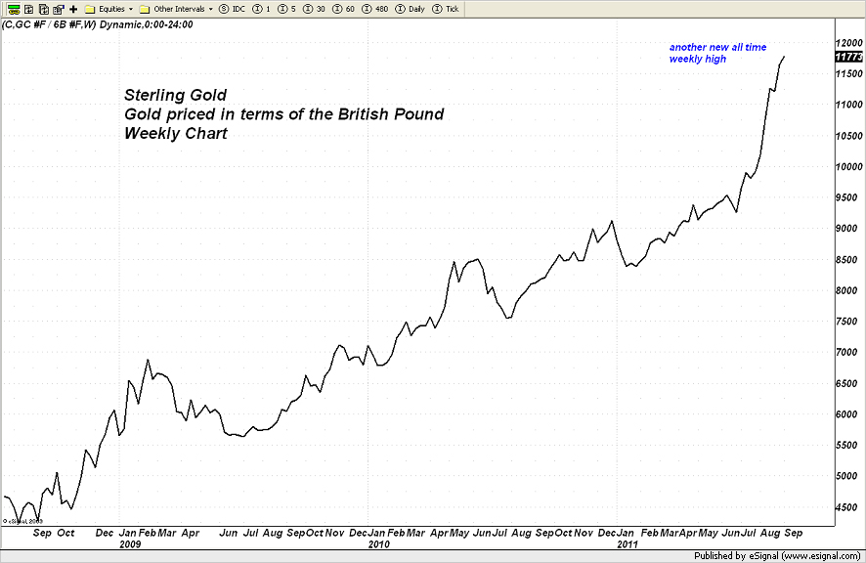
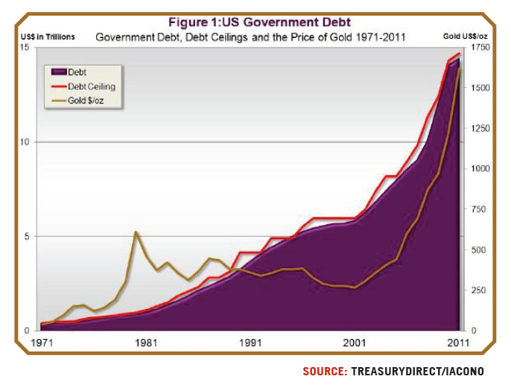
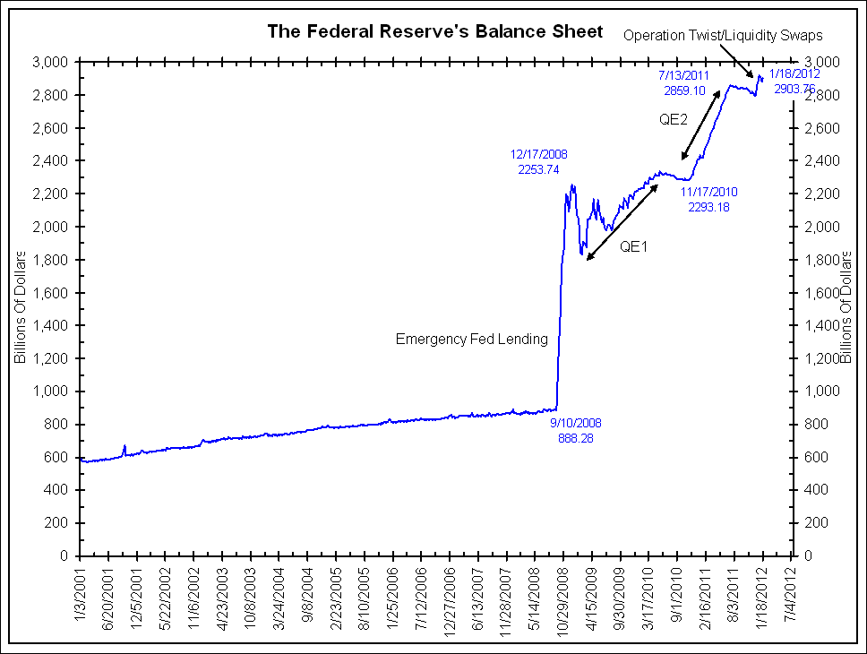
Observe the extraordinary correlation of so called quanative easing with the rise in the gold price.
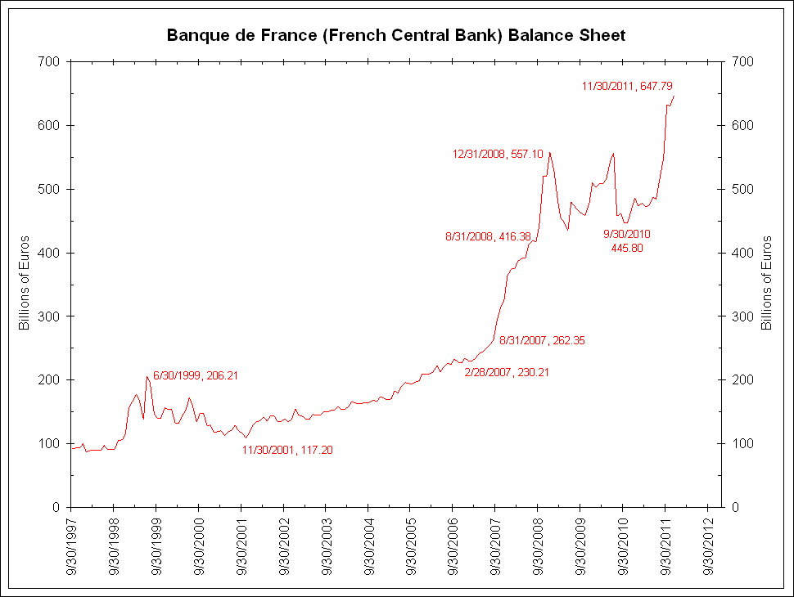
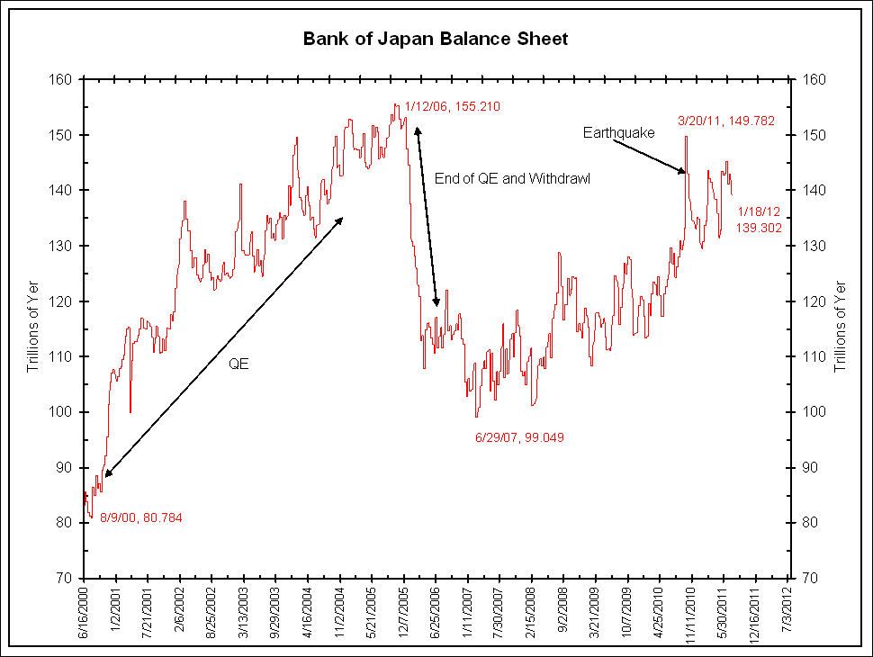
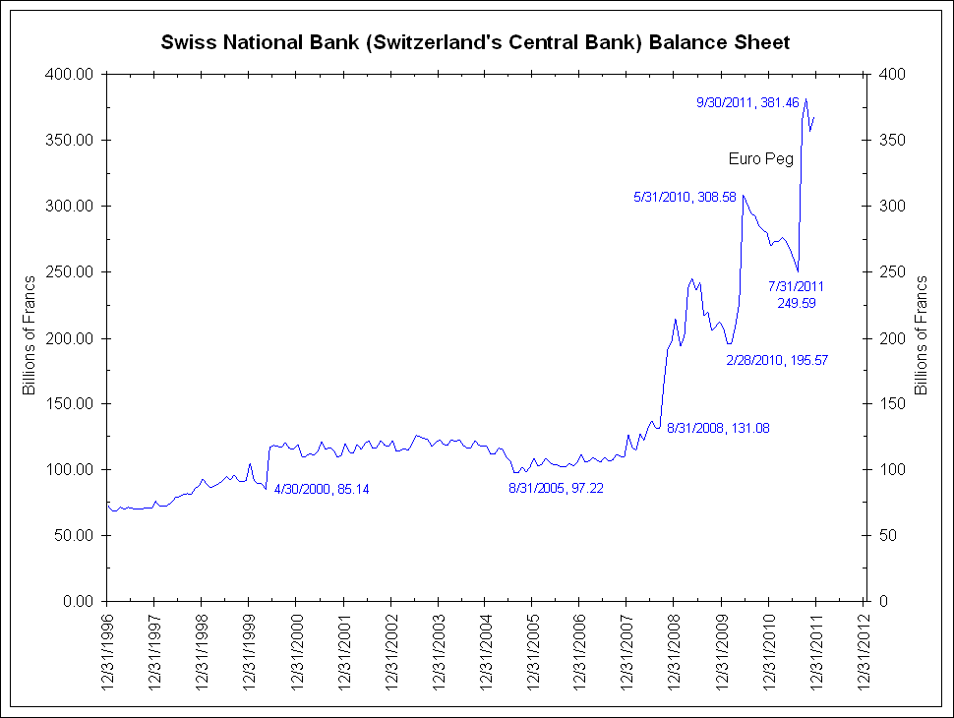
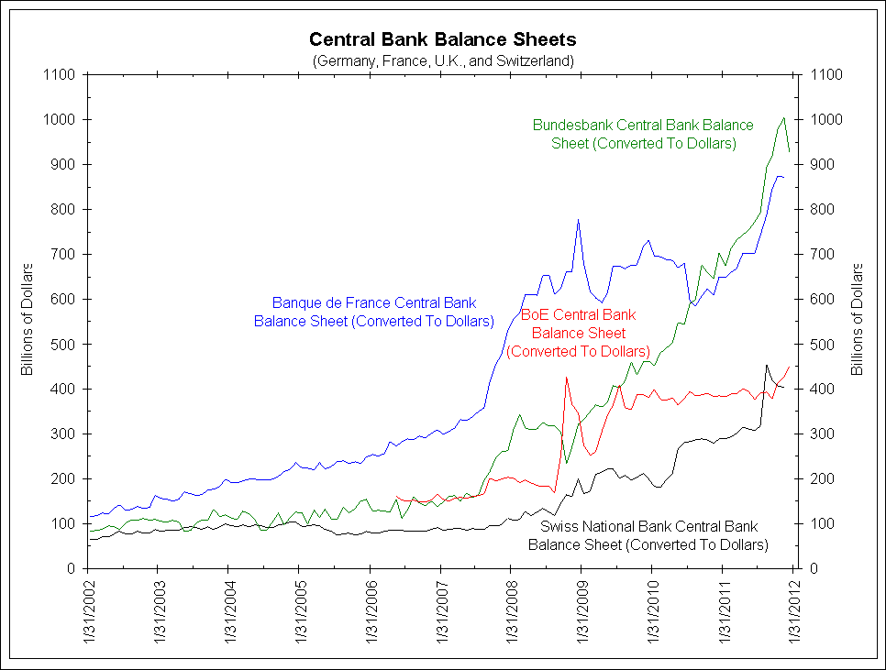
Observe the extra ordinary betrayal of Swiss Franc investors and the Swiss people.
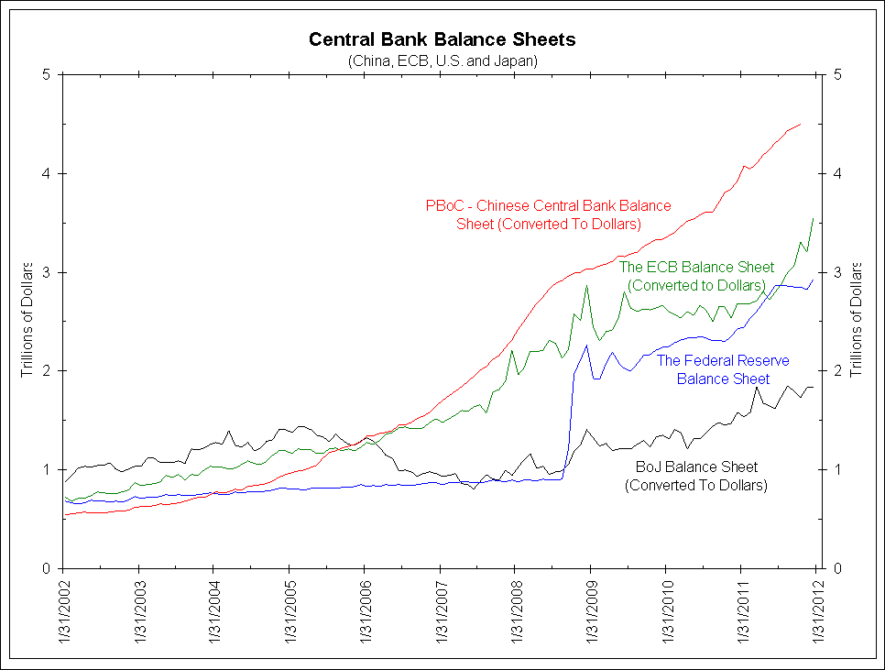
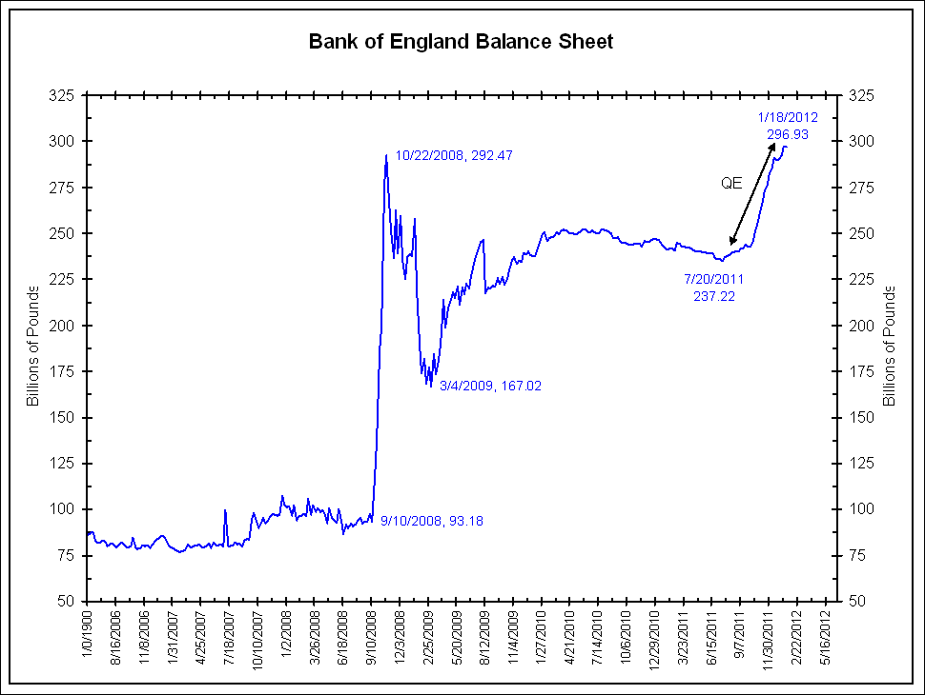
Understand the global race to the bottom in paper money.
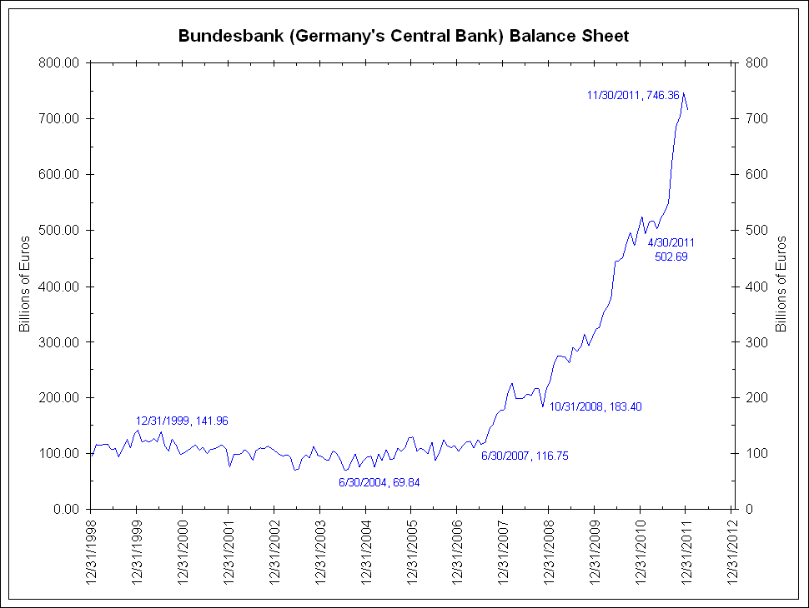
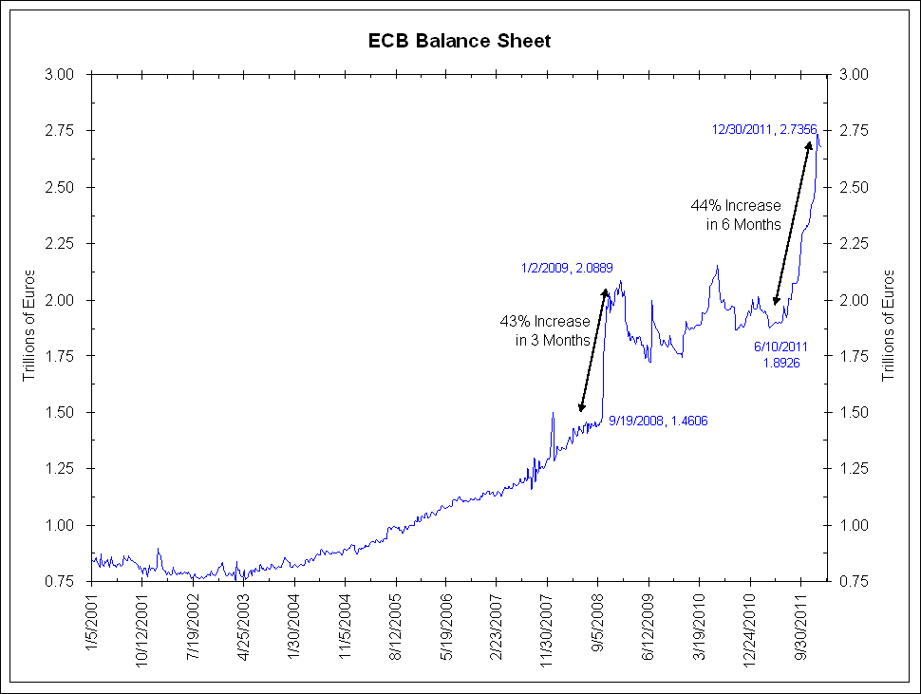
It is inconceivable that hyper inflation does not manifest itself and the end of this money printing binge.
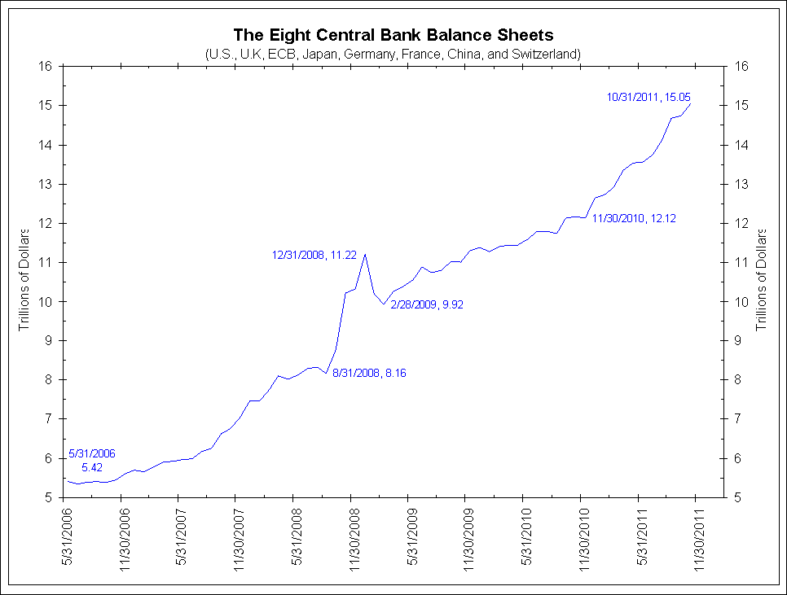
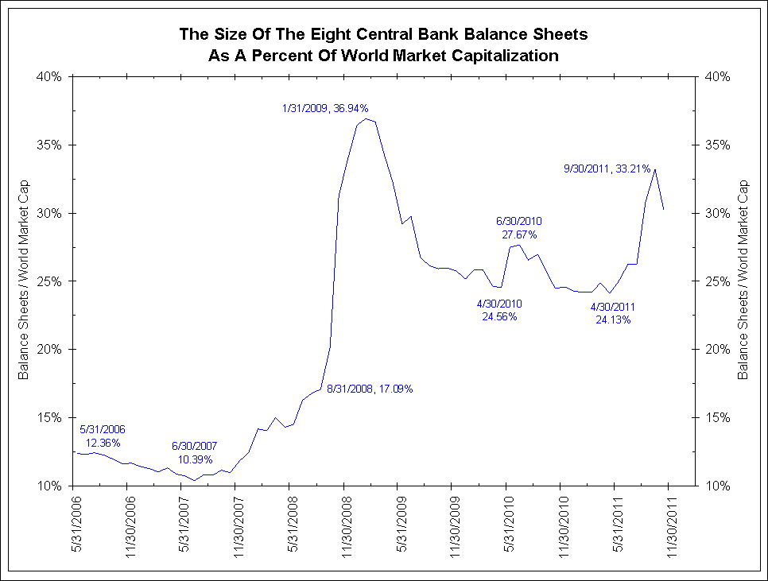
Stagflation is the only possible outcome of this policy.
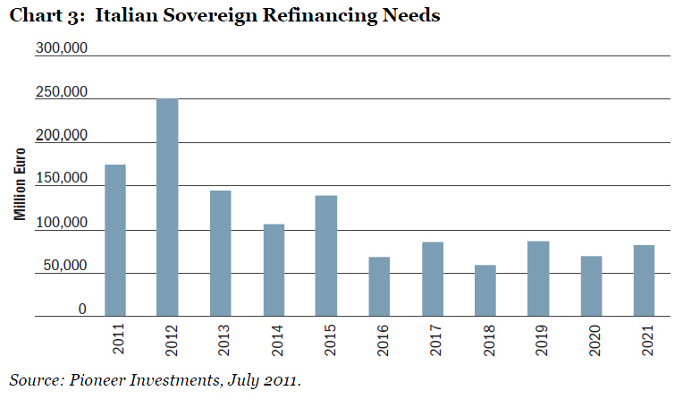
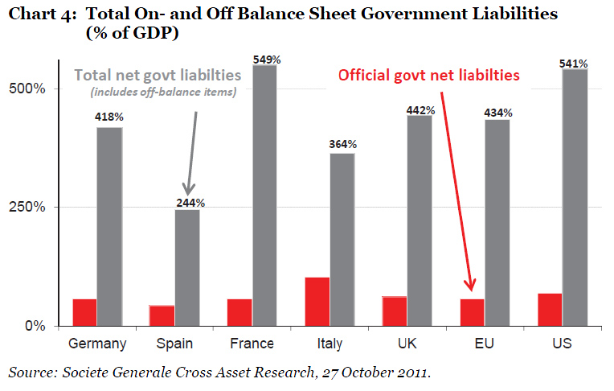

Accounts presented in this way by the PLC would ensure the directors were sent to prison.
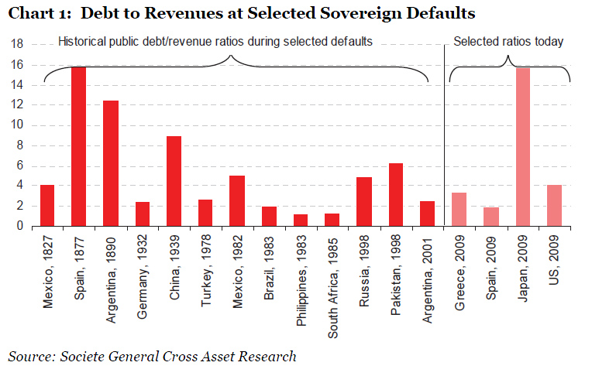

There seems to be an absurd idea that sovereign states do not go broke!

ANOTHER YEAR, ANOTHER DISASTROUS EU AUDIT REPORT AS PAYMENT 'IRREGULARITIES' RISE AGAIN

Brussels 9 November 2011. 4.6 billion Euro of payments from the EU budget - taxpayer's money - are 'irregular' according to a report released today by the European Court of Auditors.

This figure equates to around 25% of the UK's annual contribution to EU coffers.

The Court of Auditors Report on the 2010 budget shows that 'irregularities' - or possible fraud in layman's terms - are on the rise from their previous 2009 report.

The combined error rate for payments for 2010 is 3.7% or 4.6 Billion Euro.
Cohesion funding, which includes structural funds (or aid) to countries, of which Greece received some 60 Billion since joining the Euro, was worst affected with an error rate of 7.7% (3.6 Billion Euro). Next Agriculture, the largest recipient of payments from the EU budget, had an error rate of 2.3% (1.6 Billion Euro).

Most alarmingly, in the samples used by the Court of Auditors around 50% showed 'errors'. Additionally, the auditors raised the alarm over the lack of supervision on advance payments which they consider to be out of control.

Former EU Chief Accountant and UKIP MEP Marta Andreasen, commenting on the report said,

"Despite repeated assurances from the European Commission and pressure from the European Council, the way the EU makes payments from its Budget is getting worse not better. This should send alarm bells ringing across Member States governments. However, I fear there is a business as usual mentality, where 'irregularities' are tolerated despite the huge amounts of money involved that cannot be properly accounted for.

'This mentality is not helped by the terminology used by the Auditors who refer to the payments being 'partially effective'. Such contrived language is an insult to the taxpayer's whose money has effectively disappeared as the Auditors cannot get to the bottom of where it has gone.

"In any private enterprise heads would roll and the shareholders would demand change at the top. Doubtless the Commission will again try to trumpet these figures as a success. They are anything but."
This below states the USA financial position succinctly:
U.S. Tax revenue: $2,170,000,000,000
Fed budget: $3,820,000,000,000
New debt: $1,650,000,000,000
National debt: $14,271,000,000,000
Recent budget cut: $38,500,000,000
Now just remove 8 zeros and pretend it is a household budget:
Annual family income: $21,700
Money the family spent: $38,200
New debt on the credit card: $16,500
Outstanding balance on the credit card: $142,710
Total budget cuts: $385

There are no significant public spending cuts in the welfare addicted European and American Countries.

Article 125 of the Lisbon Treaty reads: “the union shall not be liable or assume the responsibility for the debts of any member state”.

Both Maastricht Treaty and the Lisbon Treaty have simply been abandoned.

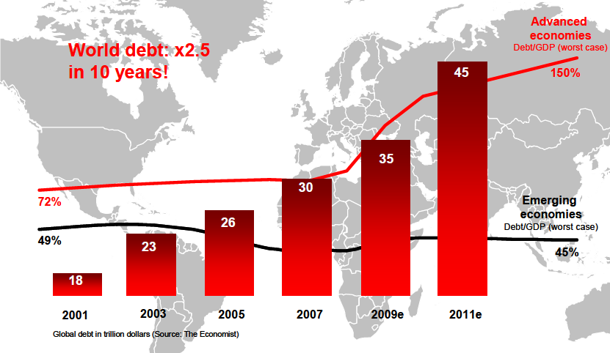

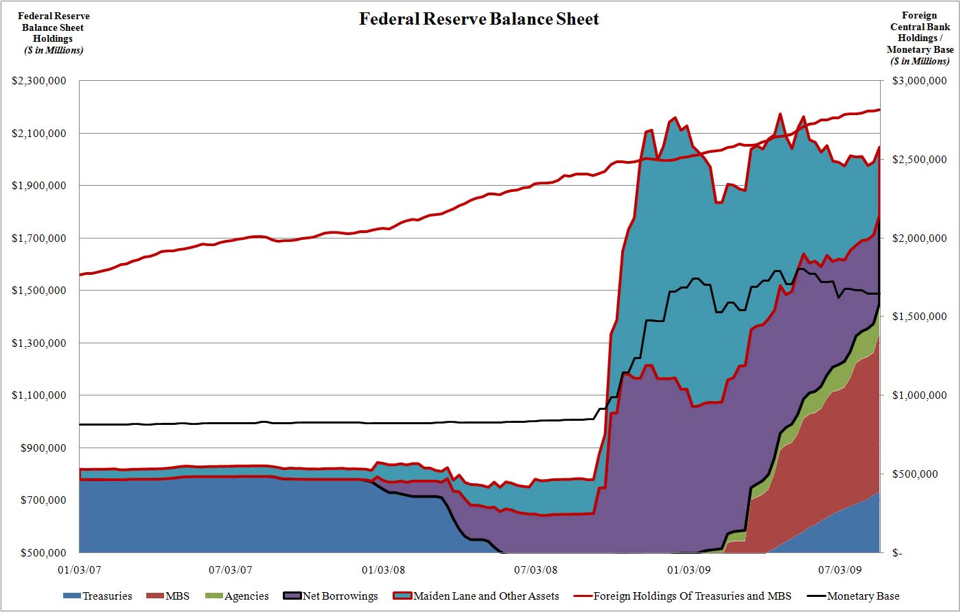
Whilst politicians and central bankers talk a good story these are the numbers.

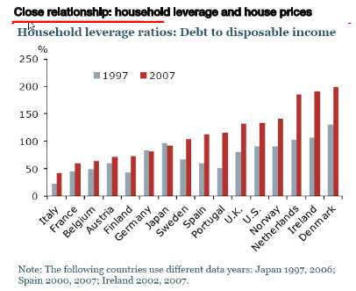

The rich get richer, the poor get poorer. It was never really true. The richer get richer and poor got richer more slowly. Today’s problem is the rich get richer and everyone else flat lines. Many of the rich get richer at the tax payers’ expense.

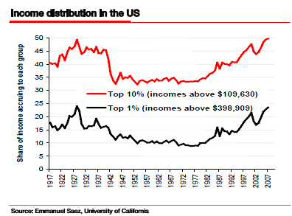

There is now a disconnect, a rift almost between not the top and bottom, but the top and middle. This is dangerous because it is the middle that foot the National Bills.
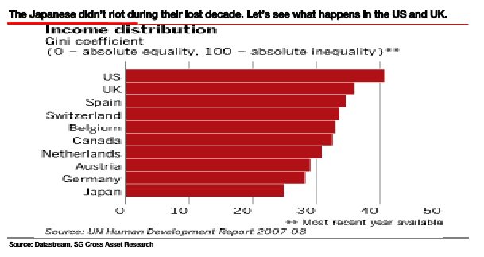
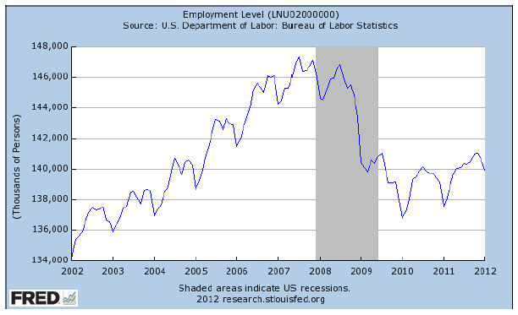
The US economy has created almost 3 million jobs in the last two years. That means they only need another 7 millions to get back to where they were in 2007! Look at the graph of the total numbers of jobs in the county, as of last month. (From the St. Louis Fed FRED database)
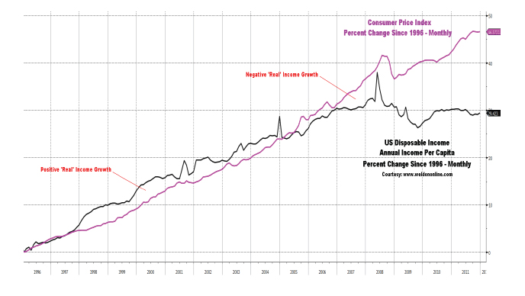
The above suggests there has been little growth in disposable income for five years.
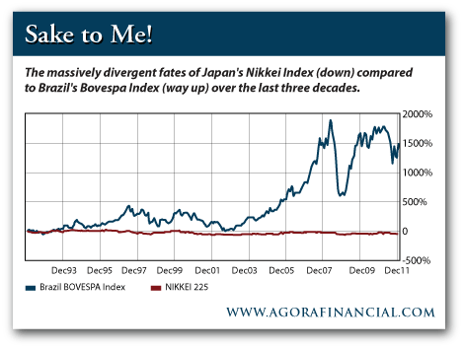
As the Duke of Wellington would have said ‘Default and be dammed!’

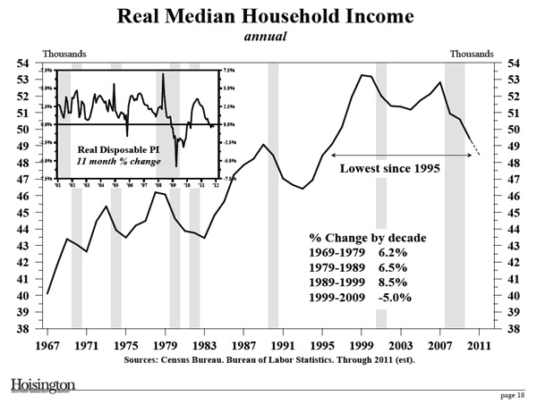

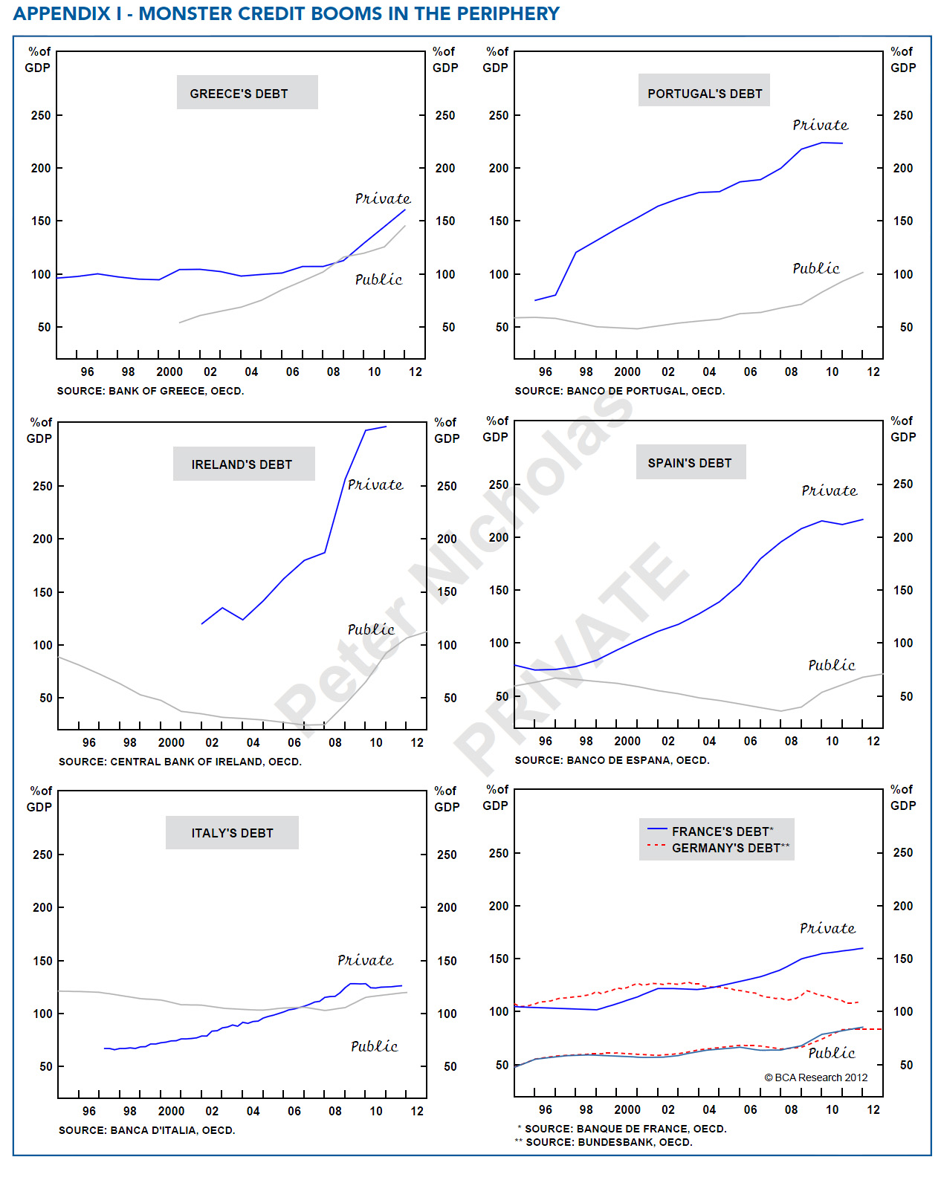
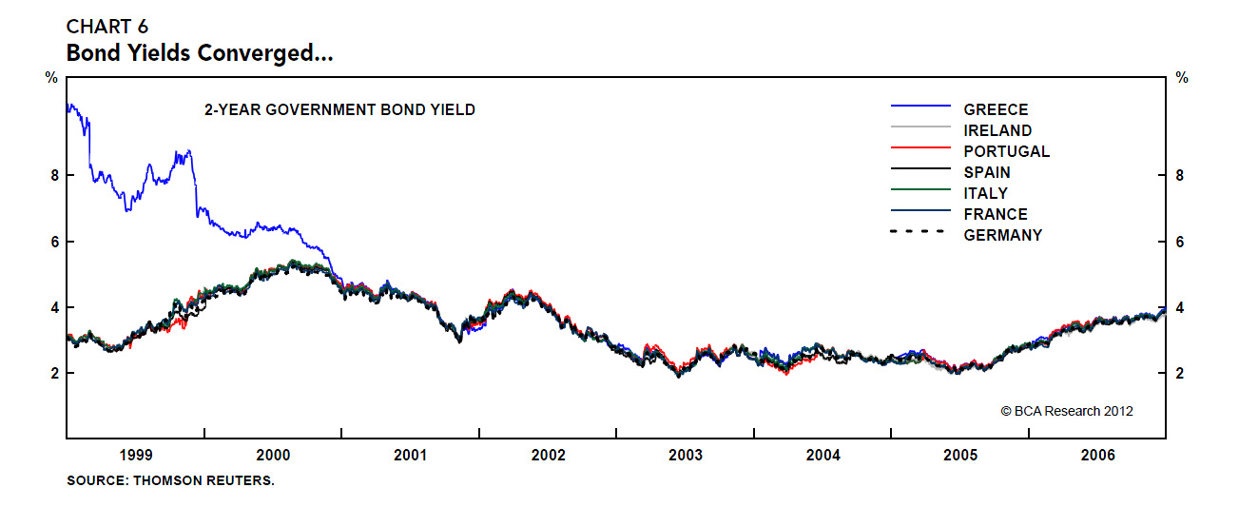
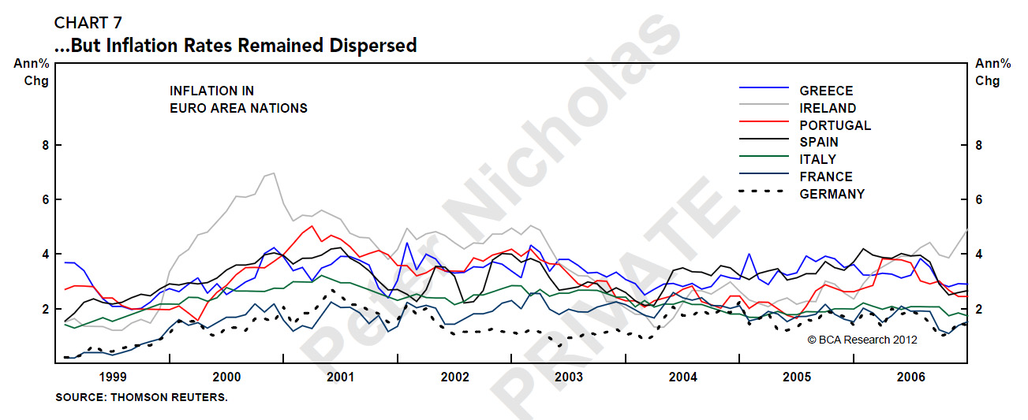
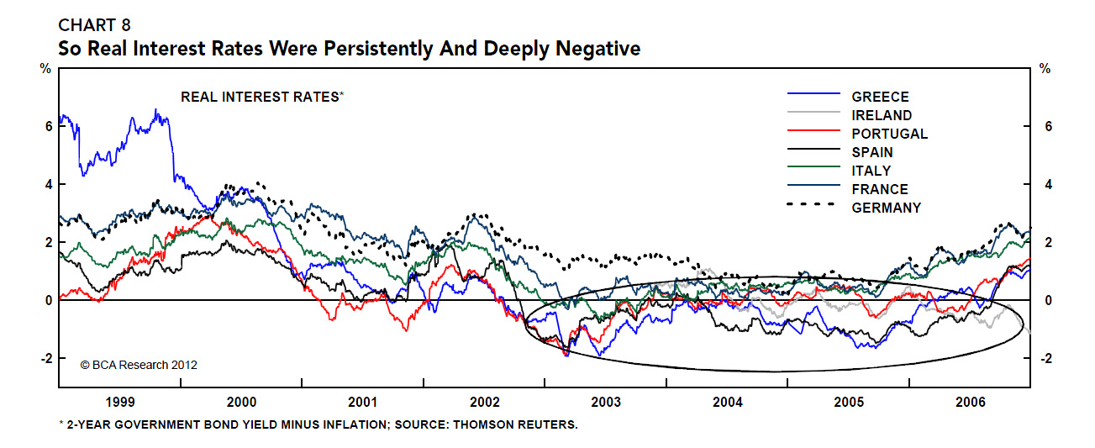
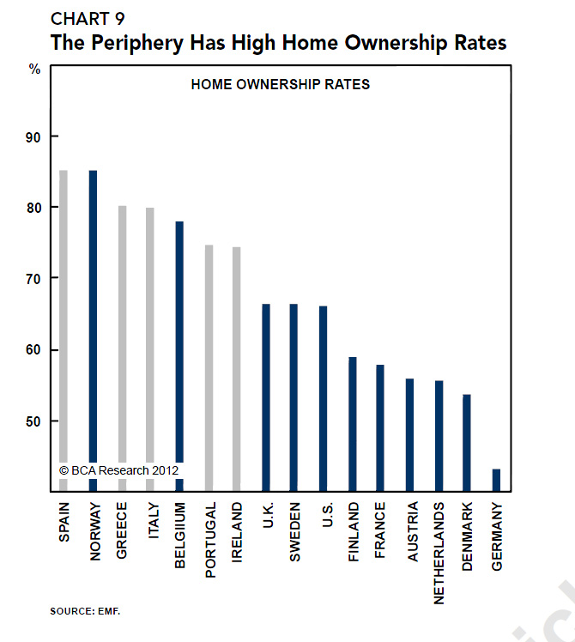

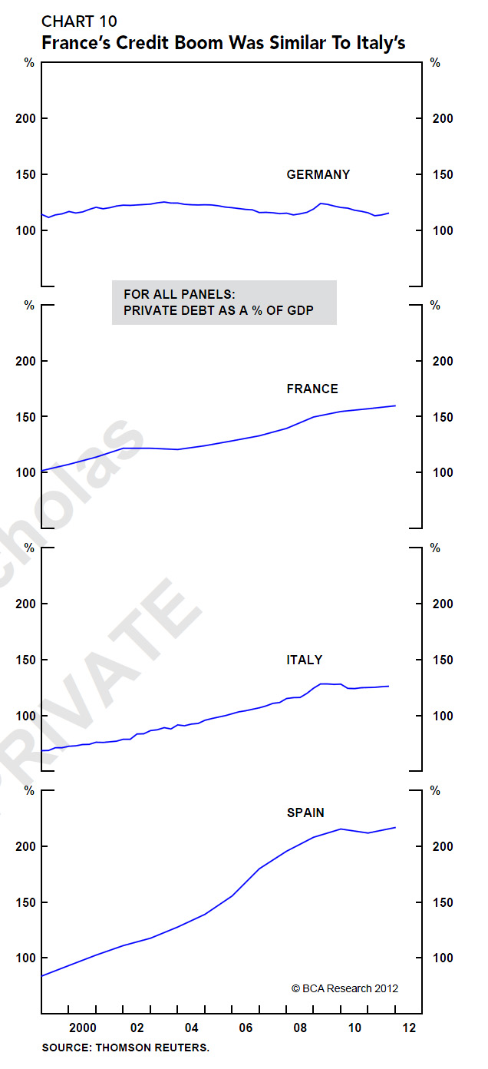
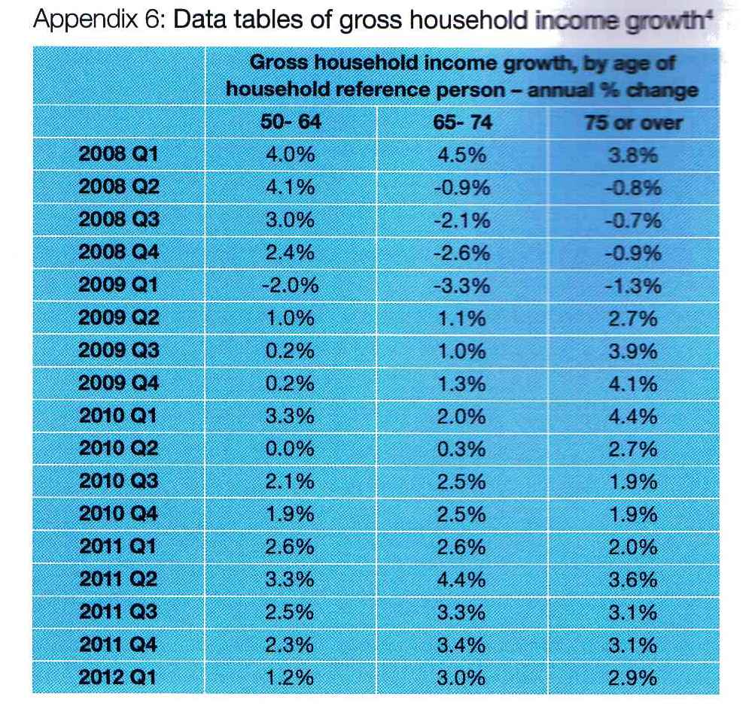

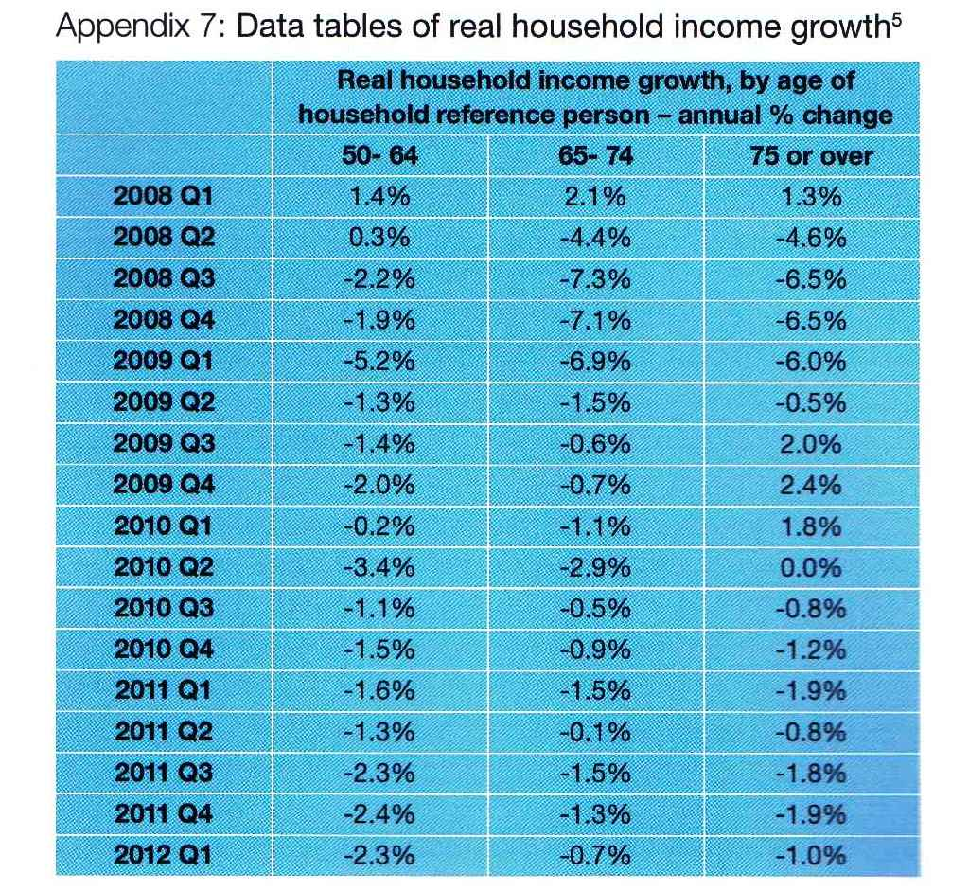
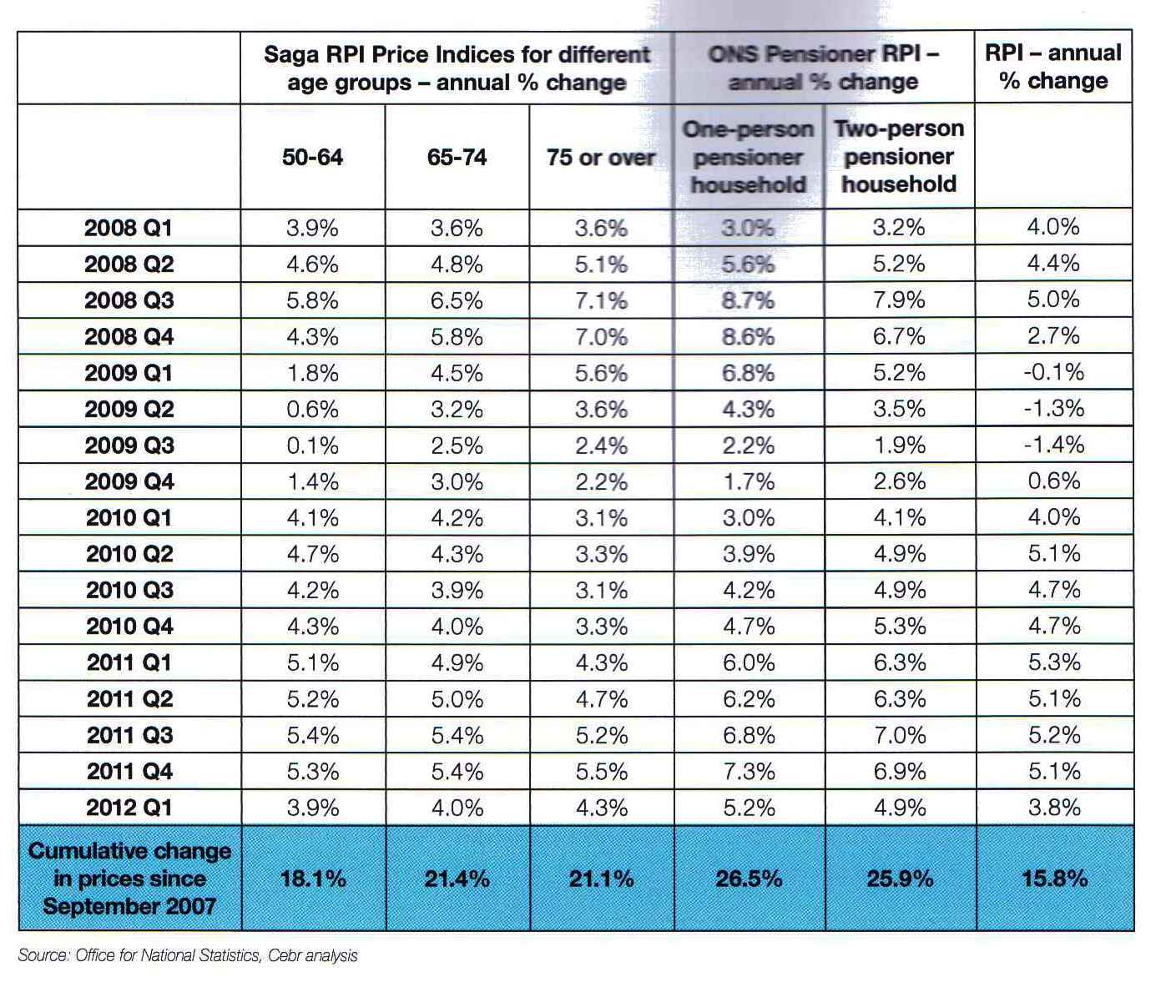

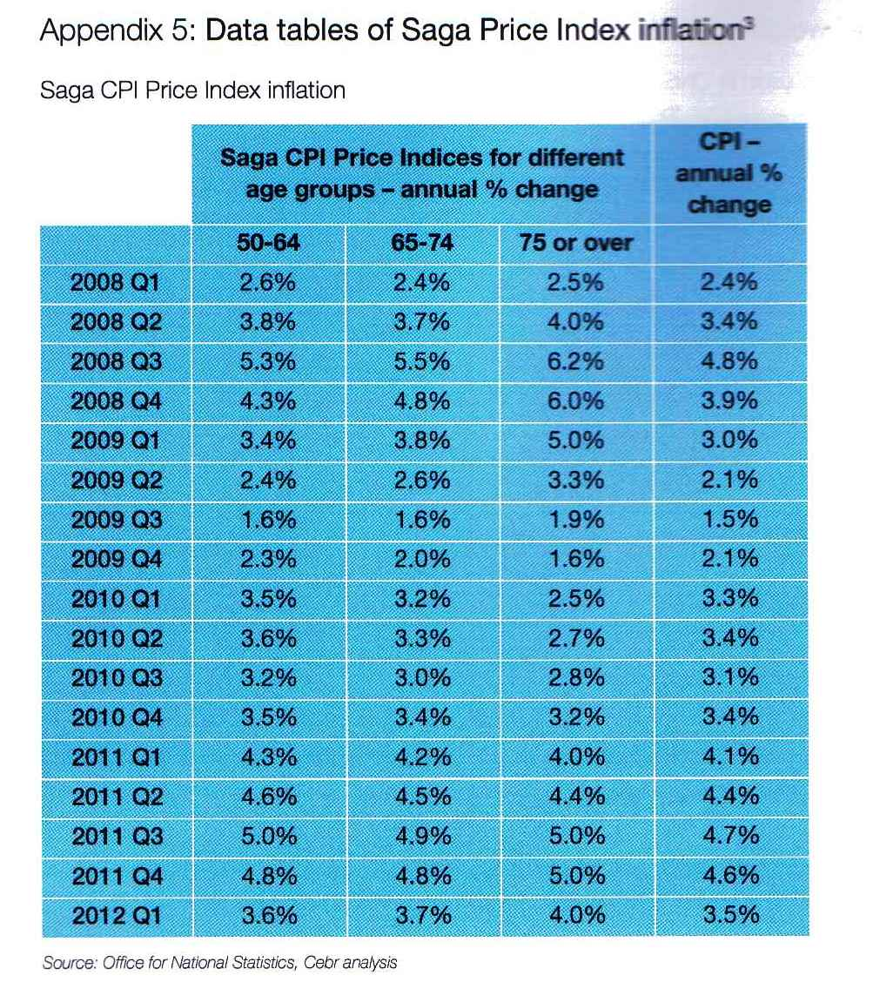

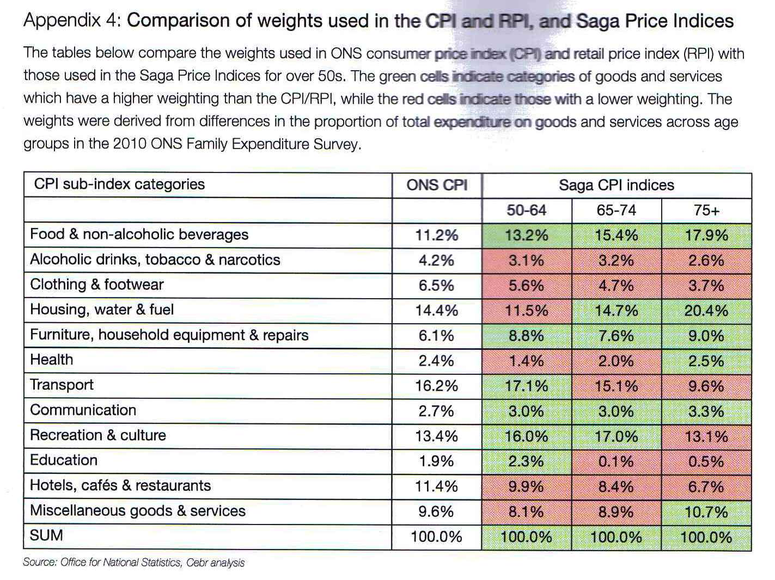
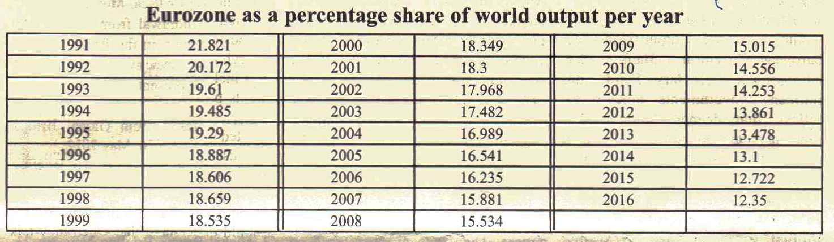

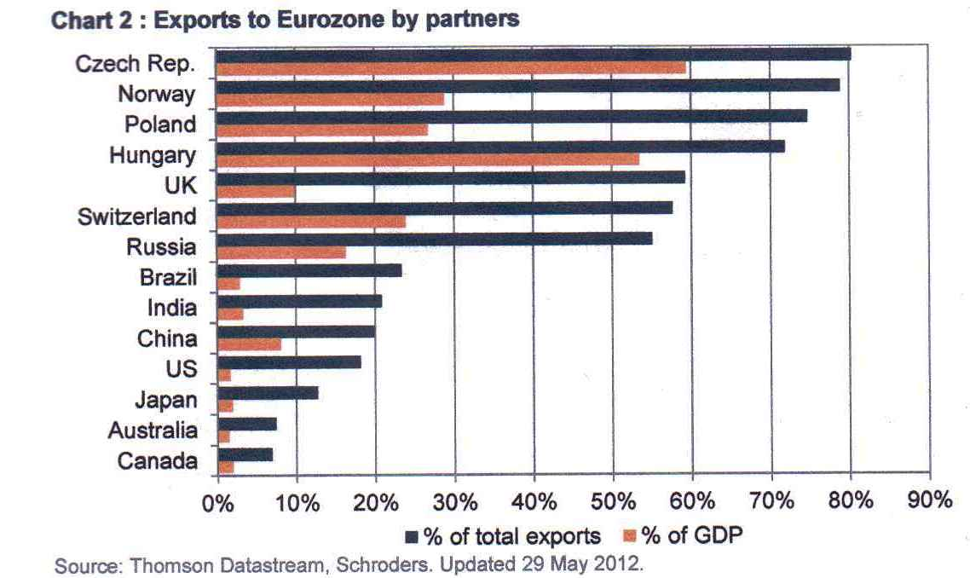

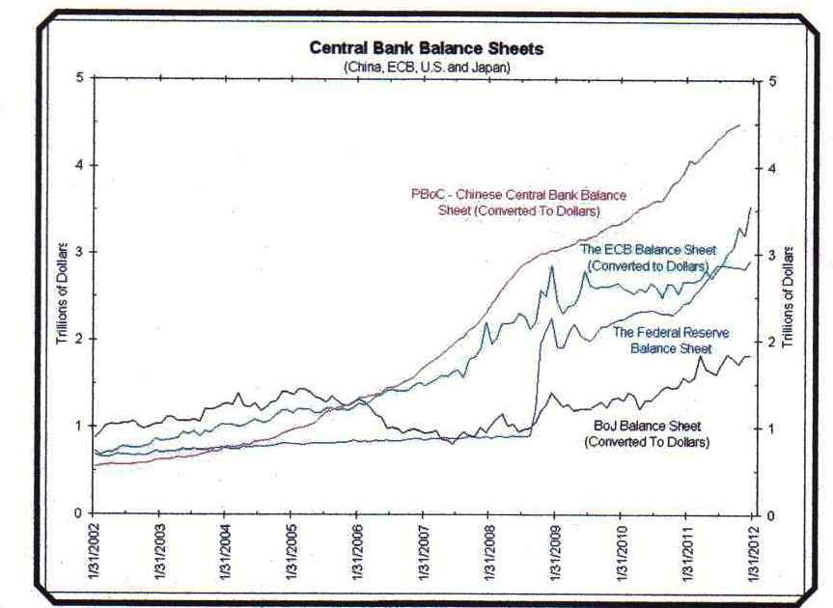
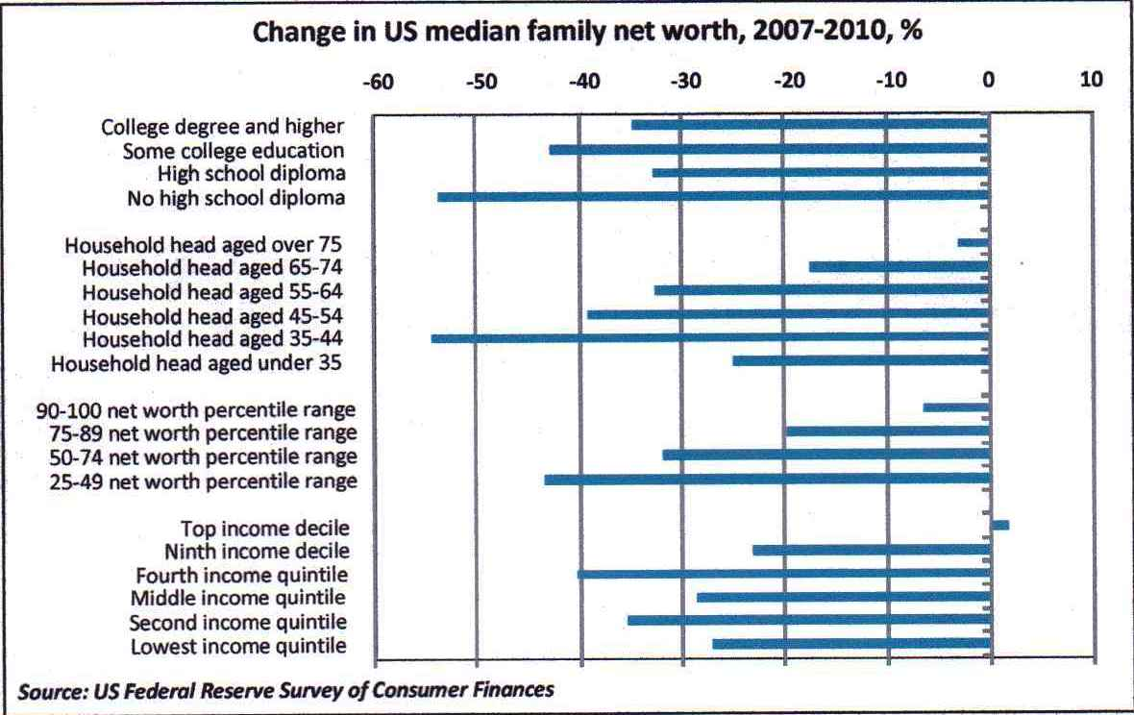

“It is a curious anomaly. State power has an unbroken record of inability to do anything efficiently, economically, disinterestedly or honestly; yet when the slightest dissatisfaction arises over any exercise of social power, the aid of the agent least qualified to give aid is immediately called for.”

- Albert Jay Nock

“The basic point is that the recession of 2001 wasn’t a typical postwar slump, brought on when an inflation-fighting Fed raises interest rates and easily ended by a snapback in housing and consumer spending when the Fed brings rates back down again. This was a prewar-style recession, a morning after brought on by irrational exuberance.

To fight this recession the Fed needs more than a snapback; it needs soaring household spending to offset moribund business investment. And to do that, as Paul McCulley of Pimco put it, Alan Greenspan needs to create a housing bubble to replace the Nasdaq bubble.”

- Krugman

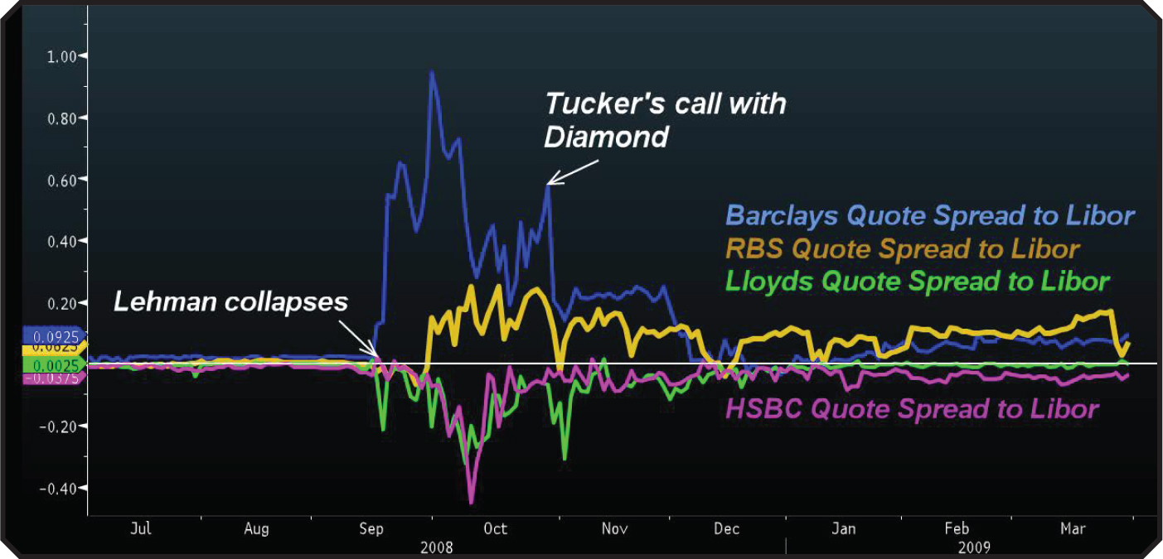
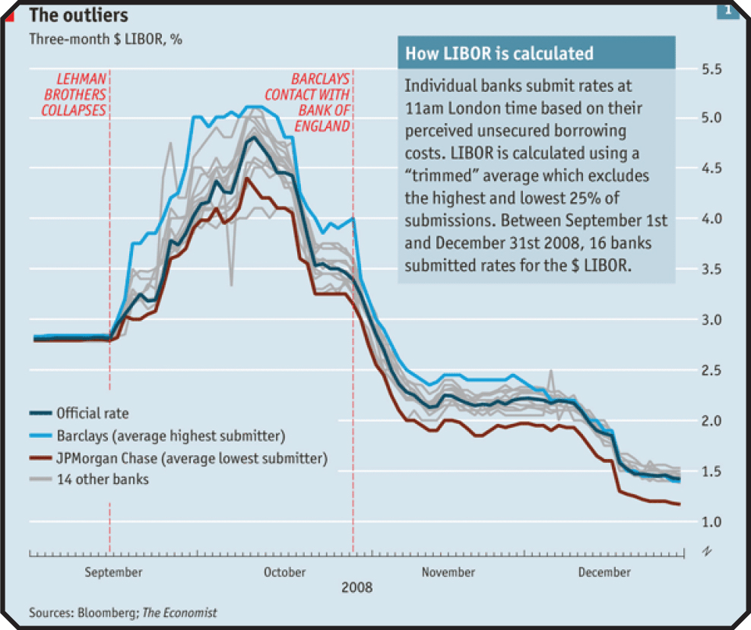

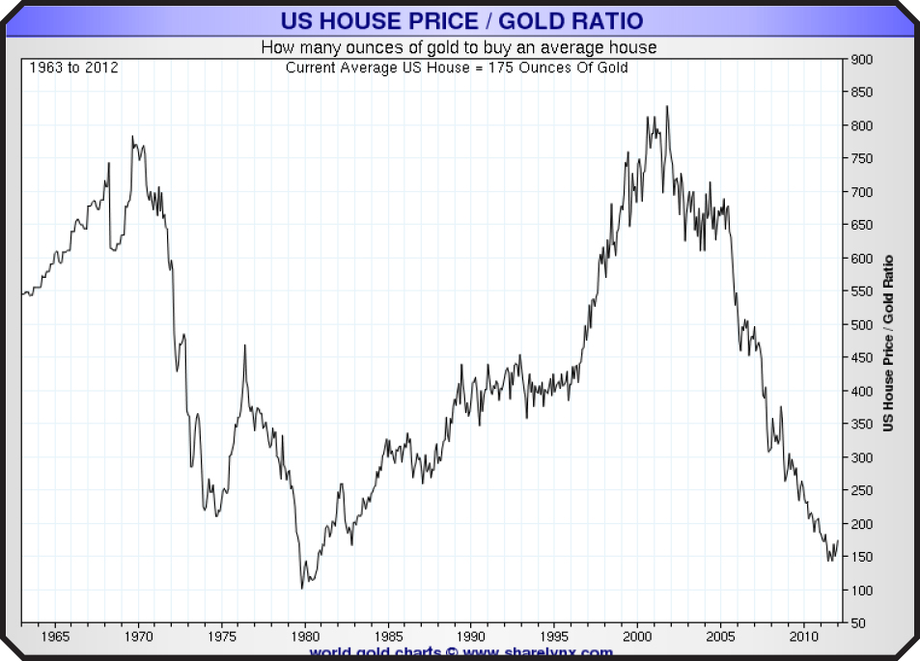
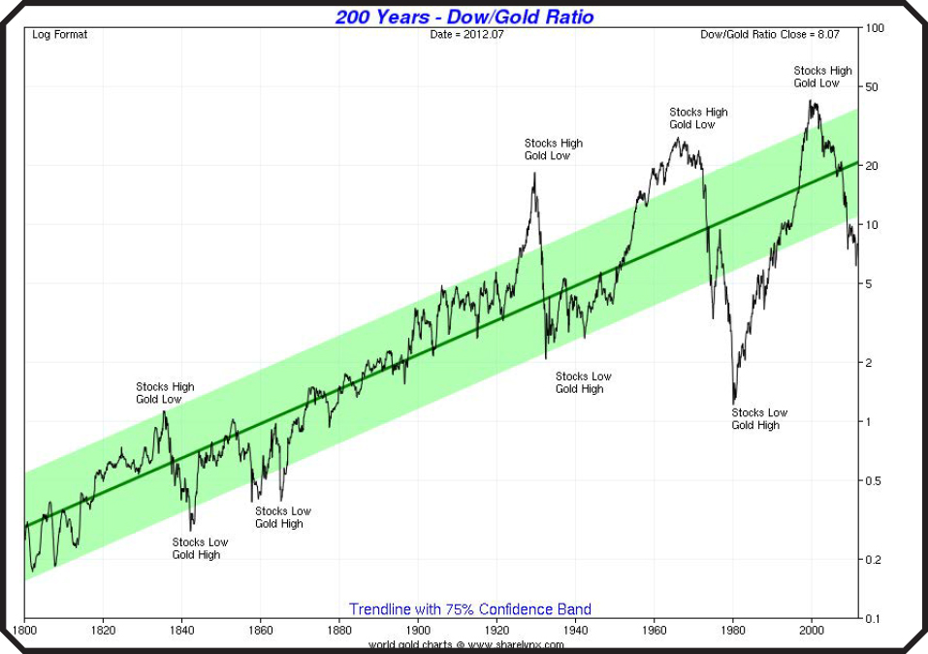
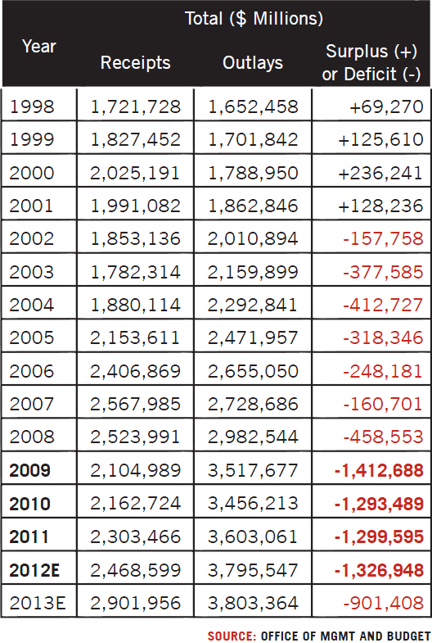
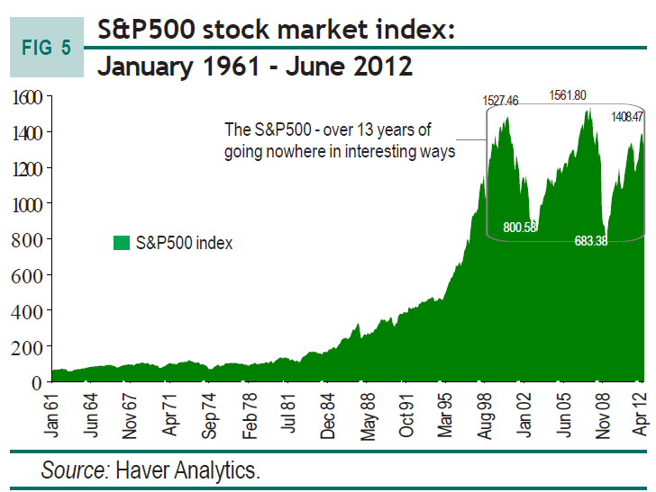
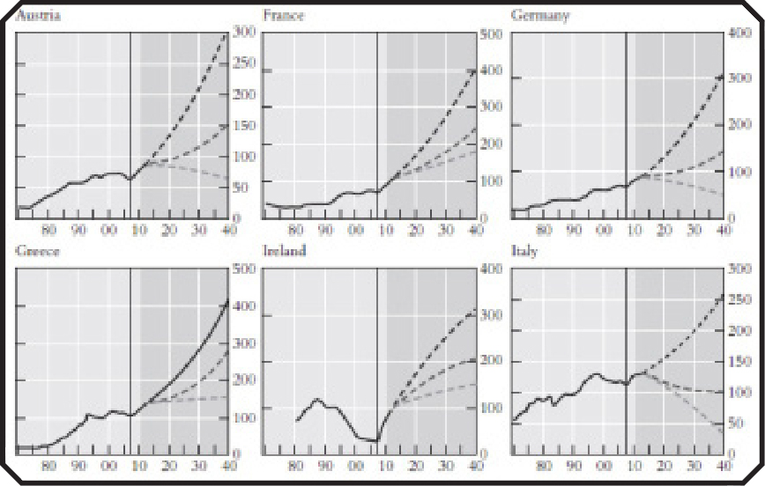
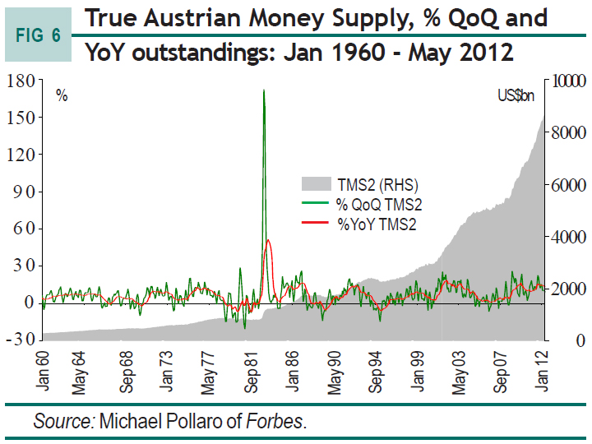
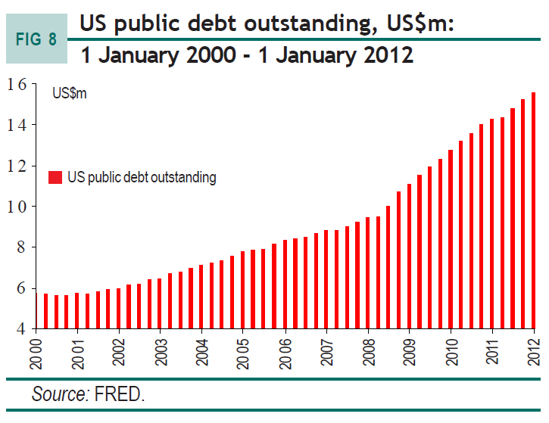
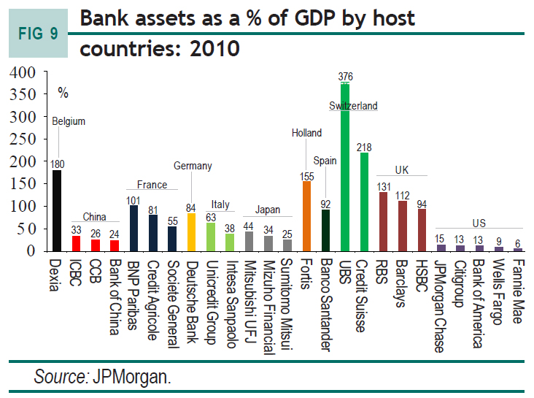
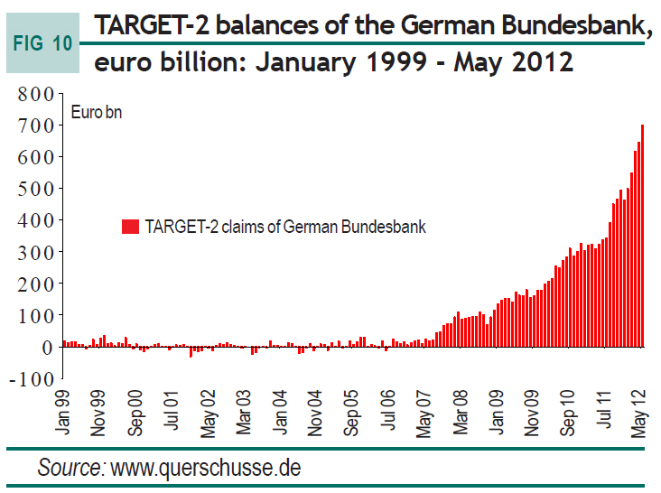
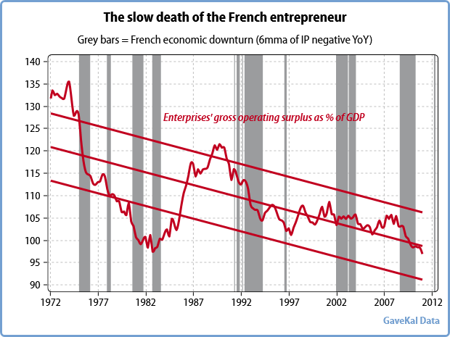
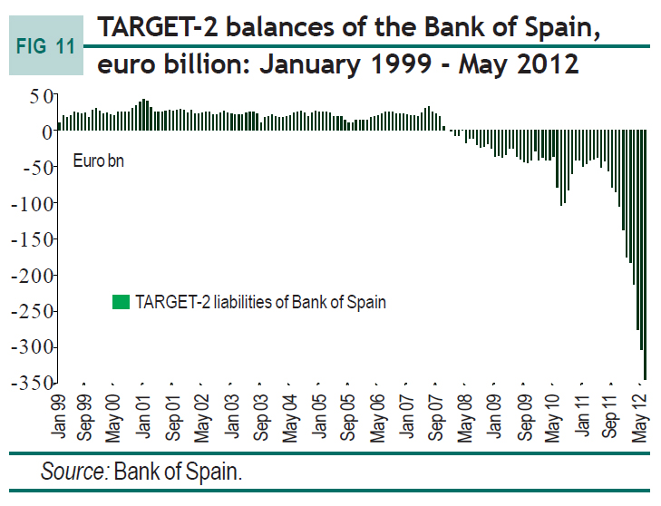
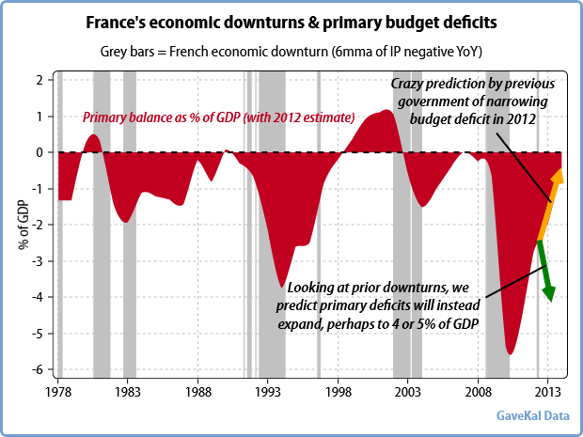
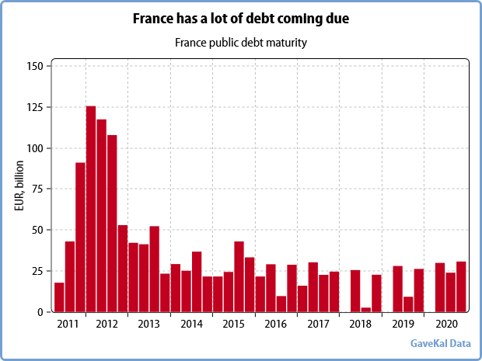

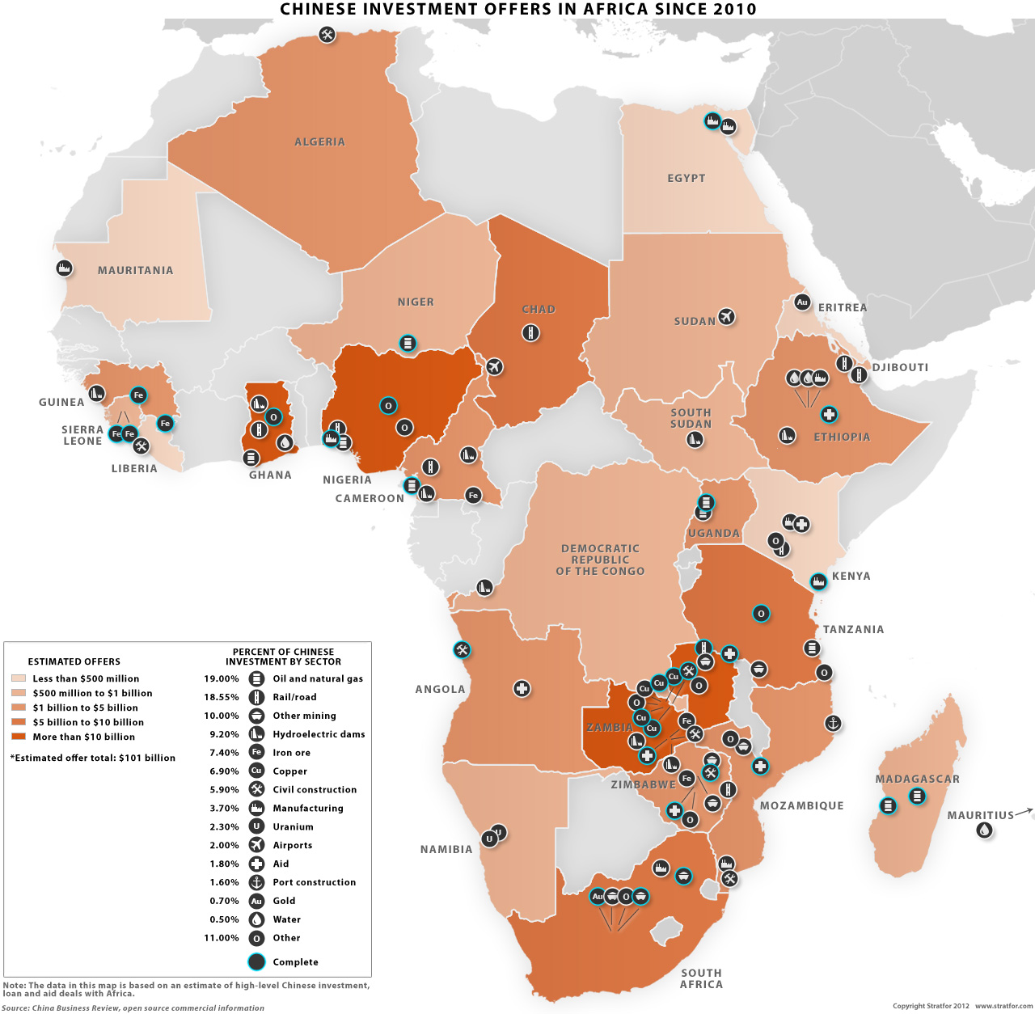

(UK Daily Telegraph): "We used to think you could spend your way out of recession and increase employment by boosting government spending,”
boomed the Prime Minister, Jim Callaghan, at the 1976 Labour Party conference.

“I tell you, in all candour,” he went on, “that that option no longer exists. And in so far as it ever did exist, it only worked on each occasion… by injecting a bigger dose of inflation into the economy, followed by a higher level of unemployment as the next step…”



